Indonesian Language Learning Based on Ecological Intelligence at the Bengawan Solo Nature School
Aldi Dwi Saputra¹, Dasa Oktaviani Br Ginting², Dhelinta Fitri Pramadhanti³, Nani Muftihah³, Kundharu Ssaddhono³
¹ Universitas Sebelas Maret 1; aldids@student.uns.ac.id
² Universitas Sebelas Maret 2; dasa_oktavia@student.uns.ac.id
³ Universitas Sebelas Maret 3; dhelintafitri@student.uns.ac.id
⁴ Universitas Sebelas Maret 4; nanimuftihah17@student.uns.ac.id
⁵ Universitas Sebelas Maret 5; kundharu_s@student.uns.ac.id
* Corresponding author: aldids@student.uns.ac.id
ORCID ID: https://orcid.org/0000-0002-8745-9572

Article History | Abstract  Ecological intelligence has a complex structure for improving education. Learning Indonesian needs to contain ecological intelligence. It aims to make students love, protect and preserve the environment. The purpose of this article is to analyze the way teachers carry out ecological intelligence mapping and assess the potential of advanced students at the Bengawan Solo Natural School. This research method is qualitative with a case study approach. Data and data sources were obtained from the results of document analysis, observation, and in-depth interviews with teachers and students. Test the validity of the data used in this study is the technique of data triangulation and source triangulation. The results of this study are that the teacher maps ecological intelligence by becoming a partner or co-parent in developing the potential that exists in students based on spiritual, intelligence, social-emotional, and physical and motor skills of students. The Bengawan Solo natural school has four types of assessment to measure the potential of students. The types of assessments are (1) moral assessments in the form of Al-Qur'an report cards; (2) leadership assessment in the form of narrative report cards; (3) cognitive and scientific assessments in the form of numerical report cards and portfolio reports; and (4) business assessment in the form of business reports. The Bengawan Solo Nature School does not only educate students to become great people in the future, but also has the character of loving nature and being useful to others.
Received 2020-00-00
Revised 2020-00-00
Accepted 2020-00-00
Published 2020-00-00
Keywords
Assessment
Ecological Intelligence
Indonesian Language
Nature School
How to cite?
Copyright © 2019 The Author(s)


Public Interest Statement
The Bengawan Solo Nature School stands as a unique educational institution that prioritizes holistic learning experiences within the context of nature and environmental awareness. In this age of rapid urbanization and detachment from nature, the school's approach holds immense promise for fostering a generation of ecologically conscious citizens. As the Indonesian language remains a crucial conduit of communication and culture, examining the interplay between language learning and ecological intelligence holds significant implications for both educational methodologies and sustainable living.

Introduction
Ecological intelligence is a new awareness in an effort to preserve nature in order to deal with global environmental problems (Friedman, 2022; Rosati, 2017). Ecology, which is a science that studies the relationship between living things and the environment, is integrated with intelligence in protecting and managing the environment efficiently (Amodio et al., 2019; Wang et al., 2019). Garden & Downes (2021) states that ecological intelligence is not just knowledge regarding environmental issues, but also perception and sensitivity to their impacts. Someone who has ecological intelligence will be sensitive to nature and have the ability to understand the interrelationships between human actions and their impacts on nature, human health, and social systems. Ecological intelligence forms humans with sensory, cognitive, and sympathetic awareness that all living things are interconnected and have intrinsic value within themselves (Garden, 2022).
Environmental problems in Indonesia are problematic that require special attention by the whole community. Environmental problems are caused by both natural and human factors (Huang et al, 2022). According to Herlina (2017) environmental problems in Indonesia include: (1) polluted rivers, (2) forest damage, (3) floods, (4) air pollution, (5) soil pollution, (6) abrasion, (7) decreased biodiversity, (8) waste problems, (9) groundwater pollution, (10) damage to marine ecosystems, (11) global warming, (12) damage to water absorption, (13) scarcity of clean water, (14) noise pollution, ( 15) wild and shabby buildings. Ecological intelligence is a smart solution in an effort to overcome environmental problems caused by human factors (Bibri & Krogstie, 2020). Therefore, ecological intelligence has a complex structure to improve education, one of which is in learning Indonesian. Learning Indonesian aims to master language skills which consist of listening, speaking, reading, and writing (Saputra et al, 2022). Learning Indonesian will be more meaningful if it integrates ecological intelligence in its learning materials and methods. Integrating ecological intelligence in education is an effort to prepare future generations who love the environment (Huang et al., 2016).
In integrating ecological intelligence in the field of education, an assessment activity is needed to see how far the target has been achieved in the learning activities that have been carried out (Kruglanski & Gigerenzer, 2018). In addition, assessment is also useful for overcoming a problem faced by teachers in implementing learning at school and helping teachers to improve learning systems in the future so that they become even better through the assessment system that is used and enforced (Seaton, 2017). It is undeniable that in implementing an assessment system, various difficulties will be found by teachers in implementing an assessment system, especially in learning Indonesian (Helda, 2022). Therefore, a study is needed to discuss ways to overcome problems that occur in an assessment of Indonesian language learning.
The importance of this research being carried out is to examine ecological intelligence-based learning as a solution in overcoming problems that occur in the implementation of assessments of Indonesian language learning at Bengawan Solo Nature School. The assessment is carried out to monitor the process, progress in learning activities and improvements regarding learning outcomes that have been carried out in natural schools which have a unique form of education that uses the universe as a place for learning, as teaching material, and as an object used in the learning process. Meanwhile, ecological intelligence is developed as a complex matter that is carried out by natural schools in providing the essence between 'environmental imperatives' and 'human nature' related to education and training on the influence of a human resource, on cultural values in society (Danylova & Salada, 2018).
This research is relevant to research conducted by Kelvin et al. (2016) who studied the ecological intelligence contained in electronic school books for junior high school Indonesian subjects. This research integrates the importance of ecological intelligence in learning Indonesian. This ecological intelligence is instilled as a form of the importance of environmental preservation through teaching language by communicating and internalizing it with knowledge of language. The integration of language and ecological intelligence, in implication, is able to awaken an ecological culture to the younger generation regarding the importance of understanding environmental issues and how we can respect our homeland by protecting it for the sake of present and future survival (Akkuzu-Guven & Uyulgan, 2021; Mirzamakhmudov et al., 2021). Ecological intelligence-based learning also teaches students to be more sensitive and responsible for the problems that exist in the surrounding environment so that later they will increase their emotions and instill values of awareness of the environment, competence and important qualifications for protecting the natural environment.
The novelty of this research is the discovery of the implementation of ecological intelligence mapping and the implementation of an assessment of the potential of students at the advanced level at Bengawan Solo Natural School. Similar research was carried out by Darmuki et al. (2017) who found that there was a special name for the assessment system at the Bogor Nature School known as SALAM (Spirit, Akhlaq, Learning, Advance and Meaning). In addition, similar research has also been carried out by (Kutnick & Manson, 2021) who found five evaluation dimensions contained in natural schools, namely skills and knowledge, students' connectedness to nature, physical and mental health, structure, inclusivity, and enjoyment that they feel during the implementation of learning activities. While research conducted by Lee & Yeon (2022) found the importance of carrying out mapping and planning in the learning system in natural schools so that revitalization can be carried out for the widespread development and implementation of ecological intelligence in students. What distinguishes this research is that researchers analyze how teachers carry out mapping activities on ecological intelligence and carry out potential assessments carried out by teachers, especially learning Indonesian at the advanced level of the Bengawan Solo Natural School.

Methods
This research is a qualitative research with a case study approach. A case study method for closely examining data in a research context. Case studies provide specific answers to a given problem that will apply in dealing with the context under investigation (Thomas, 2021). The researcher examines a single entity or phenomenon (a case), is limited by time and activity (an event, process, institution, or social group), and collects detailed information using various data collection procedures over a continuous period of time (Hancock, Algozzine, & Lim, 2021). Researchers conducted observations and in-depth interviews with teachers, students, and school principals to obtain ecological intelligence mapping data and assess students' potential. This research was conducted at the Bengawan Solo Nature School, located in Gondangsari Village, Juwiring District, Klaten Regency. Data collection techniques using observation and interviews. Test the validity of the data used in this study is the technique of method triangulation and source triangulation. The results of data analysis in the form of documents and observations are strengthened by analysis of interview data for further interpretation, formulation of results, presentation, and drawing conclusions.

Discussion

A. Ecological Intelligence Mapping
The mapping of ecological intelligence for learning Indonesian carried out at the Bengawan Solo Nature School is based on the goal of achieving the school's vision and mission. The main goal set by the Bengawan Solo Natural School is to become a partner or co-parent in developing the potential that exists in students based on the spiritual, intelligence, social-emotional, and physical and motor skills of students. The development of these four aspects has the main target with the hope that students can provide benefits for the environment and others.
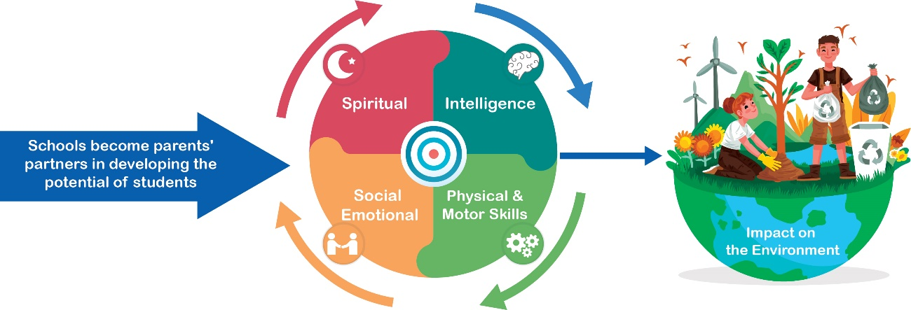
Figure 1 Mapping of Ecological Intelligence of Students
source: researcher

(a). Spiritual
The mapping of children's potential in the spiritual aspect is carried out by carrying out various religious activities. In learning Indonesian, the development of this potential is carried out by giving children an understanding of how to write the correct text for writing the word God, the name of religion, and being taught the proper use of punctuation in writing in the field of religion. In addition, in practice, children are also taught how to behave and build a harmonious life regarding human obligations to Allah SWT and the Messenger of Allah, as well as morals to fellow humans, animals, plants and the environment which are packaged in learning Indonesian.

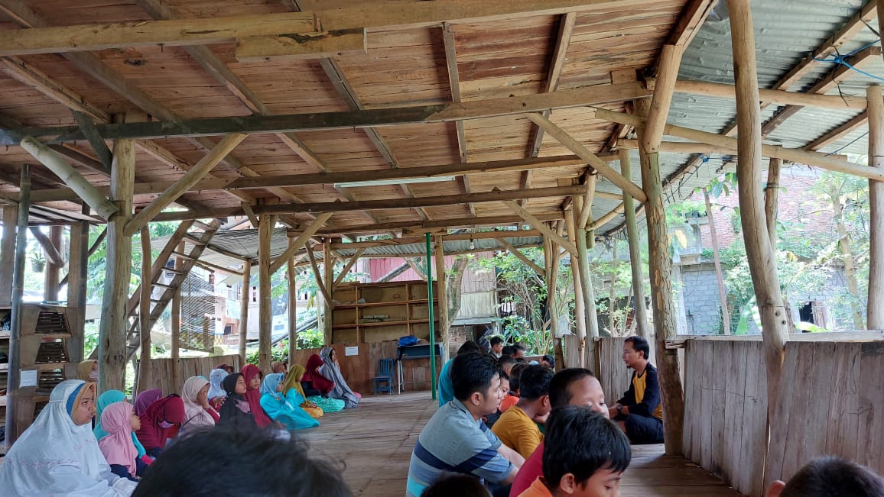
Figure 2 Collective Prayer and Stories of the Prophet after Congregational Prayers
source: researcher
Indonesian language learning is not only carried out in class during learning hours, this is because the time and place of learning at the Nature School is more flexible. After finishing the congregational prayers, the teacher tells the students stories about positive messages and good values that should be exemplified by the Prophet Muhammad SAW as a role model for humans. In addition, stories about role models in Islamic religious teachings are also given. From this story, it is hoped that students can become figures of “Rahmatan lil 'alamin” whose presence in social life is able to provide peace and compassion for humans and nature.
The mapping of spiritual-based learning becomes an important matter in the implementation of learning. Spiritual intelligence is seen as an important form of intelligence in understanding the meaning of life and as a guide in solving life problems experienced (Chester et al., 2019). This spiritual knowledge will later be able to guide the child to become a person who is more moral and has good character in socializing both with the community and with his friends because the deepening of the importance of spiritual meaning that can be firmly held as a guide will act through the relationship between the potential in the soul affectively (soul, heart and spirit) with cognitive activity in the school environment (Hajiannor et al., 2023).

(b). Intelligence
Mapping intelligence (intelligence) in learning Indonesian at the Bengawan Solo natural school is carried out by understanding and presenting factual knowledge using clear, systematic and logical language, in aesthetic works, in movements that reflect healthy children, and in actions that reflect behavior of students who have noble character when playing and learning in nature.

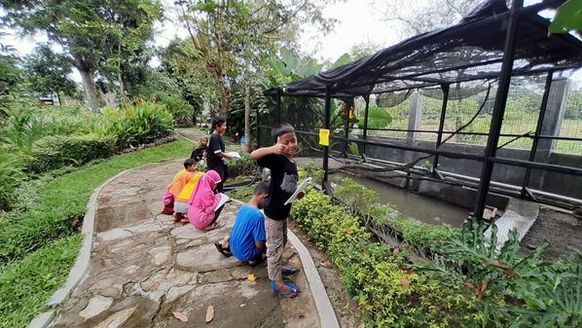
Figure 3 Poetry Writing Learning
source: researcher

Intelligence mapping (intelligence) is carried out in various ways and carried out in the surrounding natural environment. At the beginning of each Indonesian language learning theme, the teacher will provide an introductory explanation regarding the theme they will learn and the activities that students must carry out. In learning Indonesian with the theme of poetry, students will be invited to observe the surrounding environment, after which students are asked to write poetry according to what they see and feel. All Indonesian language learning is associated with nature which aims to develop students' ecological intelligence. After the poem is finished, the teacher will provide input one by one on the students' poetry. After that the poetry work will be recorded as a product produced by students. The book will be sold as a business appraisal.

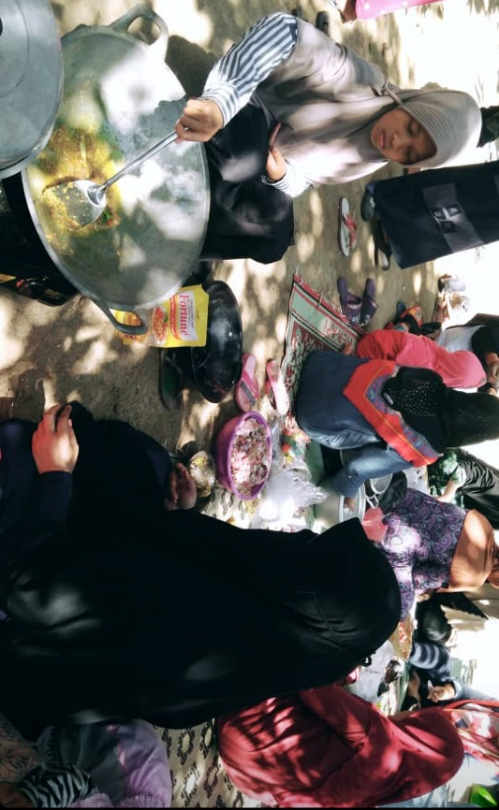
Figure 4 “Work with Parent” Program
source: researcher

Learning Indonesian procedural text materials is also integrated with the “Work with Parent” program which is implemented to further strengthen the relationship between children and their parents. Students are directly accompanied by their parents to implement the procedure text on how to cook various processed mutton. Processed goat meat will be cooked with satai, tengkleng and tongseng which are local specialties. The processed food will be eaten together and some will be distributed to the local community.

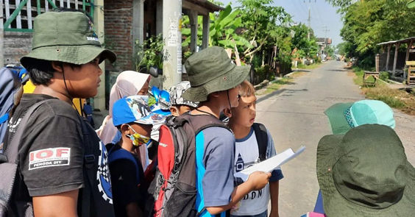
Figure 5 Learning Indonesian to Read Plans
source: researcher

Learning Indonesian to read plans also carries out outings to explore independently with classmates. Learners will be directed to find out, take notes, explore, and they will be directed to train their intelligence. If they find it difficult later, they will be guided to ask questions and not be ashamed to find out. Based on these activities, educators will later assess how far the child's knowledge will create something that is aesthetic and synergistic in reflecting healthy children with activities carried out directly in nature.
The assessment system is different from the assessment system carried out by conventional schools in general. This scoring system is in line with the opinion of Herppich et al. (2018), that different relevant assessment situations can be carried out depending on the educational system or culture implemented by the school. Therefore, in carrying out an assessment system in measuring these aspects of intelligence, natural schools involve practical assessment activities that refer to students at school and how they relate to the natural surroundings. In addition, the Bengawan Solo natural school determines characteristics that are relevant to the learning being carried out. This activity is carried out to measure assessment competencies in a valid way, by carrying out a series of representative situations that meet the criteria for aspects of student intelligence.
Based on these various activities, students learn Indonesian in a more enjoyable and meaningful way. Students are able to find a variety of new vocabulary that they use in the poems or stories they create. This activity is an effective thing to foster curiosity in logic, and more enthusiasm in implementing Indonesian language learning. Students also have work, and have recorded writing experience. In addition, students are able to develop the ability to think logically and analytically so that they are not only able to complete the Indonesian language assignments given by the teacher in class, but can also recognize the link between the Indonesian language learning that they are learning and its application in real life, so that they become better able to solve the various problems they face.
Learning activities that build the intelligence of these students are an interesting way of providing new opportunities in the field of education through attractive facilities with the help of nature (Han & Xu, 2021). Based on these activities, students will be better able to know about their desires and carry out self-development through various opportunities provided by the teacher to hone their intelligence (Lievens, 2017; Puroila et al., 2021).

(c). Social Emotional
Emotional social mapping in the Bengawan Solo natural school is carried out by looking at the skills of students in understanding and presenting the appropriate use of Indonesian vocabulary or regional languages. Students are asked to observe the environment around their house. The results of observations about healthy and unhealthy environments in their home environment will be implemented in the form of written, spoken, and visual texts. This mapping relates to individual students to be able to act well for themselves and their environment. The environment includes systems or other organisms that exist in nature.
In addition, the mapping system in the social-emotional aspect in learning Indonesian at the Bengawan Solo Nature School is carried out in relation to the way students can socialize, not only with their schoolmates, but also the way they socialize with the community and the natural surroundings. Presentation, vocabulary understanding, and appropriate way of speaking are the main things regarding the social-emotional aspect. Students are taught to be able to have sensitivity in understanding the feelings of other people by choosing and using the right Indonesian language in a variety of formal and daily activities.
The social emotional aspect is an important aspect in a learning system because it can help compensate for a learning environment that is less than optimal. Even though this aspect is often associated with emotion, this aspect has a big impact related to the attitude or motivation of children in learning (Józsa & Barrett, 2018). The results found in the assessment system with an interesting approach to the social-emotional aspect have been able to create an interesting experience and have a positive impact on the development of children's character not only in one subject, but also in other learning subjects (Junaidi et al., 2022). Students have the ability to lead themselves and give social roles, in achieving mutual benefit. These activities are related to cultivating and understanding children's ecological intelligence towards their environment by seeing whether there is emotional contact, affection, and the establishment of a strong relationship between the child and the surrounding environment (Cudworth & Lumber, 2021).

(d). Physical and Motor Skills
In mapping the physical and motor skills of students at the Bengawan Solo Natural School, edureneur and leadership activities are carried out to create children's character and develop their cognitive abilities. Every Thursday an interesting activity is carried out in the form of buying and selling which is carried out by the children of the Bengawan Solo Nature School. Students will prepare independently, starting from buying materials, making goods to be sold, selling, to sharing the results obtained with their friends. From this activity it is expected to be able to map the potential of students in aspects of courage, business spirit, how to calculate profits, and how students carry out a fair distribution of results.

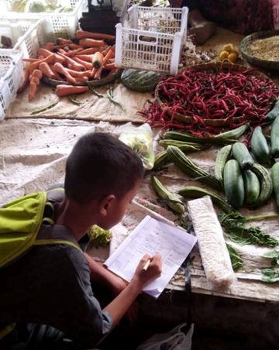
Figure 6 Students Shop at Traditional Markets
source: researcher

The result of implementing these activities is being able to build an independent mentality of students by being accustomed to getting something by working hard and lawfully. The method used is to learn to do business both independently, in groups, and learn directly from various professions by visiting or inviting to school. It is hoped that this will build a generational mentality that appreciates various professions and their benefits. In addition, this activity becomes an activity that can develop physical and motor activities in each student.
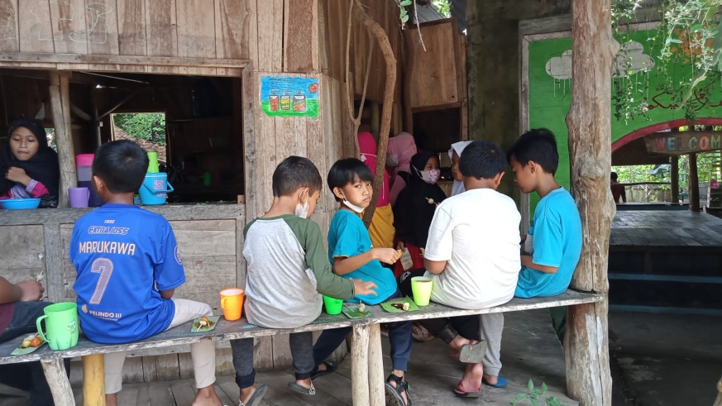
Figure 7 Edupreneur and leadership activities
source: researcher

Physical and motor mapping makes it easier for teachers to be able to see students' abilities in remembering, solving problems, and paying attention to the surrounding environment as best as possible, as well as seeing the development of students in their physical and motor skills. In addition, these activities can also increase social interaction and create opportunities for children to be directly involved in activities with their friends so that they will feel that they can be accepted and supported by other people (Kesäläinen, Suhonen, Alijoki, & Sajaniemi, 2022).

B. Assessing the Potential of Learners
The assessment of the potential of students at the Bengawan Solo Natural School is divided into 4 types of assessment. The types of assessment are (1) Moral assessment in the form of Al-Qur'an report cards; (2) Leadership assessment in the form of narrative report cards; (3) Cognitive and scientific assessment in the form of numerical report cards and portfolio reports; and (4) Business assessment in the form of business reports.
(a). Moral assessment
Moral assessment aims to make students become role models that are useful in social life. The exemplary character of children is formed through learning ethics which reviews good and bad behavior, the obligations of a Muslim towards Allah SWT and the Messenger of Allah, as well as morals towards fellow humans, animals, plants and the environment.
Students are equipped with nature, which is potential. The potential that exists in students will be directed and accustomed so that students always do good. Moral assessment emphasizes learning that brings students closer to what they know to be truth and good behavior to forms of action that reflect the value of this understanding in a real and concrete way.
To achieve a moral assessment, the teacher always provides examples and habits that include faith, worship (learning to pray in congregation at the mosque), learning to read the Koran, memorizing the Koran, emulating the stories of the prophets and messengers and salafus sholih. The form of Moral Assessment is more flexible, because the assessment is not only based on memorizing the Koran, but also the daily behavior of students in the school environment. The teacher can reprimand students when they do inappropriate behavior, after that the teacher will provide the right example. Moral assessment is also carried out by peers, after learning is finished the teacher will open a discussion forum for students to evaluate one another.
The final results of the moral assessment are recapitulated in the form of Al-Quran report cards which contain students' memorization and student morals in narrative form. Moral assessment is expected to be able to give positive messages and good values that have been exemplified by Rasulullah SAW as a role model sent by Allah SWT for humans, can also be emulated by teachers and then followed and emulated well by students as the next generation and prospective world leaders in the future.
The results of this study are in line with the findings of Suprihatin et al. (2023) who concluded that the development of moral assessment can be integrated into subjects with the aim that students are able to use knowledge, study, and internalize values and social skills to develop noble character which is manifested in daily behavior. Harmawati, Sapriya, & Bestari (2022) also found the same thing that evaluating noble morals is a way of building character. Therefore, moral assessment is very important to measure the development of a child's personality in behaving towards fellow humans, animals, plants, and the environment.

(b). Leadership Assessment
Assessment of leadership or leadership is defined as an assessment of students' ability to lead themselves and give social roles. Leadership assessment aims to develop attitude learning so that each student can have a strong character in the preparation process to become a quality leader in the future. In the leadership assessment, there are stages of competence in achieving the target goals. One of the methods used is by carrying out outbound, leadership training, night camp, OTFA (Out Tracking Fun Adventure), Backpaker (grade 5), Expedition (Class 6). Leadership assessment is expected so that students can practice learning the value of leadership in their lives more prepared and mature.
In this case, the assessment system is carried out independently by each teacher. In addition, leadership assessment activities are carried out or to see children's independence, such as leading the class, nurturing their younger siblings, and leading themselves. Furthermore, activities where children are given foster parents to hone the child's independence and in the end carry out evaluation activities to build character in children.
The results of this study are in line with Charteris, & Smardon (2022) which concluded that students are positioned as active decision makers who work with teachers and colleagues in determining their own learning direction. In addition, Parrish's research (2015) concluded that leadership assessment measures emotional intelligence related to empathy, inspiring and guiding others, and managing oneself responsibly. Therefore, it is very important to conduct an assessment to measure the emotional intelligence and social awareness of students as future leaders.

(c). Cognitive Assessment and Science
This assessment aims to foster curiosity in logic, to explore the verses of Allah SWT, both the Qouliyah and Qauniyah verses. As well as being enthusiastic and having Ghiroh in researching the regular pattern of Allah SWT's laws in nature and the Book of Allah. Cognitive assessment is designed and developed to meet the needs of students for learning activities that pay attention to the growth of students' logic and analysis. Cognitive assessment has the belief that the birth of a creative and innovative generation cannot be separated from the ability of students to be able to think critically, the Logic Curriculum at SD Alam Bengawan Solo has achievement standards and a number of activity designs that are expected to hone children's logical and analytical thinking skills so that they not only can complete the tasks given by the class facilitator, but also be able to recognize the relationship between the knowledge being studied and its application in real life. That way, students at Alam Bengawan Solo Elementary School will grow into a generation that is smart and able to think logically and analytically so that they are able to solve the various problems they face.
Cognitive assessment at the Bengawan Solo Natural School also has a special method of implementation because good education is also born from appropriate teaching strategies and in accordance with the growth of students at each level. Several activities for cognitive and scientific assessment of students will be carried out using methods such as discussions, outings, work with parents, saint projects or social projects, and various extracurriculars.
Therefore, educational practitioners/facilitators who are also responsible for the quality of learning will receive various guidance over time, ranging from classroom management training, curriculum review workshops and also strategies for dealing with students. This is useful for ensuring students get a quality learning experience and in accordance with the sunnatullah at school and also at home. Cognitive and scientific assessment at the Bengawan Solo Natural School is carried out in the form of numerical report cards and portfolio reports. Report cards are the same as other conventional schools because they are both from the Department of Education, only portfolio report cards are different, because schools develop them.
The results of this study are in line with Rahmawati (2019) who concluded that the development of cognitive assessment based on Student Active Learning can increase the critical thinking of elementary school students. Another study was conducted by Sotelo & Dixon (2014) who found that cognitive assessment measures the psychology of students in adapting and defining objects and events in their environment. Therefore, through cognitive assessment, teachers can measure the learning process of students who are oriented to direct experience, capture the relationship between learning experiences at school and apply them to life, and the material being taught can have a positive impact on their behavior in everyday life.

(d). Business Assesment
The Business Assessment at the Bengawan Solo Nature School aims to foster a spirit of independence, being able to manage finances as the forerunner of students' entrepreneurial mentality. Business assessment is carried out as an effort to build an independent mentality, students will get used to getting something by working hard and lawfully. The method used is to learn to do business both independently, in groups, and learn directly from various professions by visiting or inviting to school. Therefore, business assessment is expected to shape the character and mentality of students who appreciate various professions and their benefits. Business assessment is carried out in the form of business reports in the form of narratives containing business reports from students.
Business assessment in learning Indonesian is related to literacy entrepreneurship. The results of this study are relevant to research conducted by Wulansari, Zulianto, & Ulya (2021) which concluded that the implementation of high school Indonesian teachers in Surakarta has implemented literacy entrepreneurship but has not been maximized. The implementation of literacy entrepreneurial competence is still at the theoretical level and in practice it has not been implemented. Therefore, business assessment in Indonesian language learning conducted by the Bengawan Solo Nature School is something new. Business assessment is very important to prepare Indonesian human resources to compete in the global free market era. This is because business assessment can measure students' entrepreneurial spirit.

Conclusion
Assessment of Indonesian language learning based on ecological intelligence is very much needed in the current era. Mapping ecological intelligence and assessing the potential of students conducted by the Bengawan Solo Nature School can be used as an example for other schools. It is intended that students as the next generation of the nation have the character of loving nature and others. The results of this study indicate that schools and parents must become partners in developing ecological intelligence in students based on spiritual, intelligence, social-emotional, and physical and motor skills of students. The results of this research can practically be considered by schools in developing and mapping students' ecological intelligence. In addition, the results of this study indicate that in assessing the potential of students, the Bengawan Solo Nature School has 4 types of assessment, namely (1) Moral assessment in the form of Al-Qur'an report cards; (2) Assessment of leadership in the form of narrative reports; (3) Cognitive and scientific assessment in the form of numerical reports and portfolio reports; and (4) Business assessment in the form of business reports. The results of this study are practically used as material for consideration for Indonesian language teachers in order to be able to provide a more varied assessment and to be able to measure ecological intelligence and students' potential.

Funding: This research was funded by the Indonesian Educational Fund Management Institution (LPDP)
Acknowledgments: Thank you to all stakeholders of the Bengawan Solo Natural School who have supported this research. Researchers expressed gratitude to the Indonesian Educational Fund Management Institution (LPDP) for fully funding this research. Researchers also appreciated LPDP for funding their study in the Master's Program in Indonesian Language Education, Faculty of Teacher Training and Education, Sebelas Maret University, Surakarta.
Conflicts of Interest: The authors declare no conflict of interest.
Author Bionote

Aldi Dwi Saputra is a master's student in Indonesian language education, Universitas Sebelas Maret, Surakarta. He is an awardee Indonesian Educational Fund Management Institution (LPDP) scholarship.

Dasa Oktavia Br Ginting is a master's student in Indonesian language education, Universitas Sebelas Maret, Surakarta

Dhelinta Fitri Pramadhanti is a master's student in Indonesian language education, Universitas Sebelas Maret, Surakarta. He is an awardee Indonesian Educational Fund Management Institution (LPDP) scholarship.

Nani Muftihah is a master's student in Indonesian language education, Universitas Sebelas Maret, Surakarta. He is an awardee Indonesian Educational Fund Management Institution (LPDP) scholarship.

Kundharu Saddhono is a professor in Indonesian language education at Universitas Sebelas Maret, Surakarta. research interests include a wide range of topics related to Indonesian Language and Literature Teaching, applied linguistics, Indonesian local wisdom, and Indonesian Language for Foreign Speakers. He has published many international journal articles and books and actively participated in national and international conferences and academic workshops. SCOPUS ID: 55571941200.

References
Akkuzu-Guven, N., & Uyulgan, M. A. (2021). Are University Students Willing to Participate in Environmental Protection Activities (EPAs)? – Sub-dimensions of Ecological Intelligence as Predictors. Journal of Education in Science, Environment and Health, 7(3), 269–282. https://doi.org/10.21891/jeseh.960912
Amodio, P., Boeckle, M., Schnell, A. K., Ostojíc, L., Fiorito, G., & Clayton, N. S. (2019). Grow Smart and Die Young: Why Did Cephalopods Evolve Intelligence? Trends in Ecology & Evolution, 34(1), 45–56. https://doi.org/10.1016/J.TREE.2018.10.010
Arvanitis, A., Touloumakos, A. K., & Barrable, A. (2022). Parents’ Perceptions of UK Forest School: Descriptive and Evaluative Aspects. Forests, 13(8), 1–11. https://doi.org/10.3390/f13081314
Bibri, S. E., & Krogstie, J. (2020). Environmentally data-driven smart sustainable cities: applied innovative solutions for energy efficiency, pollution reduction, and urban metabolism. Energy Informatics, 3(1), 1–59. https://doi.org/10.1186/S42162-020-00130-8/TABLES/7
Charteris, J., & Smardon, D. (2022). Leadership for assessment Capability: Dimensions of Situated leadership Practice for enhanced Sociocultural assessment in Schools. Leadership and Policy in Schools, 1-13. https://doi.org/10.1080/15700763.2021.1910715
Chester, K. L., Klemera, E., Magnusson, J., Spencer, N. H., & Brooks, F. M. (2019). The role of school-based health education in adolescent spiritual moral, social and cultural development. Health Education Journal, 78(5), 582–594. https://doi.org/10.1177/0017896919832341
Cudworth, D., & Lumber, R. (2021). The importance of Forest School and the pathways to nature connection. Journal of Outdoor and Environmental Education, 24(1), 71-85.
Darmuki, A., Nurkamto, J., & Saddhono, K. (2017). Evaluating Information-processing-based Learning Cooperative Model on Speaking Skill Course. Journal of Language Teaching & Research, 8(1). http://dx.doi.org/10.17507/jltr.0801.06
Danylova, T., & Salata, G. (2018). The Ecological Imperative and Human Nature: A New Perspective on Ecological Education. Мiждисциплiнарнi Дослiдження Складних Систем, 12, 17–24. https://doi.org/10.31392/2307-4515/2018-12.2
Friedman, S., Gibson, J., Jones, C., & Hughes, C. (2022). ‘A new adventure’: a case study of autistic children at Forest School. Journal of Adventure Education and Outdoor Learning, 1-17.
Garden, A. (2022). An exploration of children’s experiences of the use of digital technology in forest schools. Journal of Adventure Education and Outdoor Learning, 1-15.
Garden, A., & Downes, G. (2021). A systematic review of forest schools literature in England. Education 3-13, 1-17.
Hajiannor, H., Saddhono, K., Elihami, E., Kurdi, M. S., & Kurdi, M. S. (2023). Analysis of the Content and Accuracy of Multicultural Values in Islamic Religious Education and Moral Textbook. AL-ISHLAH: Jurnal Pendidikan, 15(1), 211-218. https://doi.org/10.35445/alishlah.v15i1.2859
Han, Z., & Xu, A. (2021). Ecological evolution path of smart education platform based on deep learning and image detection. Microprocessors and Microsystems, 80, 103343. https://doi.org/10.1016/j.micpro.2020.103343
Hancock, D. R., Algozzine, B., & Lim, J. H. (2021). Doing case study research: A practical guide for beginning researchers.
Harmawati, Y., Sapriya, A. A., & Bestari, P. (2022). Systematic Literature Review of Moral Education in Schools. Journal of Positive School Psychology, 6(8), 8716-8728.
Helda, T. (2022). Online-Based Evaluation Model on Teacher Students: a Case Study in the Time Covid-19 Pandemic. Gramatika STKIP PGRI Sumatera Barat, 8(1), 38–49. https://doi.org/10.22202/jg.2022.v8i1.4638
Herlina, N. (2017). Environmental issues and environmental law enforcement in Indonesia. Jurnal Ilmiah Galuh Justisi, 3(2), 162-176. http://dx.doi.org/10.25157/jigj.v3i2.93
Herppich, S., Praetorius, A. K., Förster, N., Glogger-Frey, I., Karst, K., Leutner, D., ... & Südkamp, A. (2018). Teachers' assessment competence: Integrating knowledge-, process-, and product-oriented approaches into a competence-oriented conceptual model. Teaching and Teacher education, 76, 181-193.
Huang, S. M., Soepriyanto, G., Audrelia, J., Fahlevi, M., Aljuaid, M., & Grabowska, S. (2022). An exploration of circular water management accountability: A case from Indonesia. Heliyon, 8(9), e10556.
Huang, T. C., Chen, C. C., & Chou, Y. W. (2016). Animating eco-education: To see, feel, and discover in an augmented reality-based experiential learning environment. Computers & Education, 96, 72–82. https://doi.org/10.1016/J.COMPEDU.2016.02.008
Junaidi, F., Suwandi, S., Saddhono, K., & Wardani, N. (2022). Improving students’ social intelligence using folktales during the covid-19 pandemic. International Journal of Instruction, 15(3), 209-228. https://doi.org/10.29333/iji.2022.15312a
Józsa, K., & Barrett, K. C. (2018). Affective and social mastery motivation in preschool as predictors of early school success: A longitudinal study. Early Childhood Research Quarterly, 45, 81-92.
Karmila, N., & Suchyadi, Y. (2020). Supervisi Pendidikan Di Sekolah Alam Bogor. JPPGuseda | Jurnal Pendidikan & Pengajaran Guru Sekolah Dasar, 3(1), 31–33. https://doi.org/10.33751/jppguseda.v3i1.2011
Kesäläinen, J., Suhonen, E., Alijoki, A., & Sajaniemi, N. (2022). Children’s play behaviour, cognitive skills and vocabulary in integrated early childhood special education groups. International Journal of Inclusive Education, 26(3), 284-300.
Kruglanski, A. W., & Gigerenzer, G. (2018). Intuitive and deliberate judgments are based on common principles. The Motivated Mind, 104–128. https://doi.org/10.4324/9781315175867-4
Kutnick, P., & Manson, I. (2021). Social life in the primary school: Towards a relational concept of social skills for use in the classroom. The Social Child, 165–187. https://doi.org/10.4324/9781315784748-9
Lee, N. E., & Yeon, P. S. (2022). Needs analysis and revitalization planning for School Forest Welfare Services using mixed method. Forest Science and Technology, 18(3), 98–107. https://doi.org/10.1080/21580103.2022.2104935
Lievens, F. R. O. (2017). Institutional Knowledge at Singapore Management University Practical Intelligence , Emotional Intelligence , and Social Intelligence. 342–364.
Löfgren, H., & Löfgren, R. (2017). Grades in the eyes of our parents: a narrative approach to educational resilience in pupils’ stories of getting their first grades. Nordic Journal of Studies in Educational Policy, 3(2), 165–178. https://doi.org/10.1080/20020317.2017.1343624
Mirzamakhmudov, O. T., Mamajanov, M. M., & Turaev, B. B. U. (2021). Ways Of Developing Ecological Culture In The Education Of The Young Generation. The American Journal of Applied Sciences, 3(05), 86–93. https://doi.org/10.37547/tajas/volume03issue05-15
Parrish, D. R. (2015). The relevance of emotional intelligence for leadership in a higher education context. Studies in Higher Education, 40(5), 821-837. https://doi.org/10.1080/03075079.2013.842225
Puroila, A. M., Juutinen, J., Viljamaa, E., Sirkko, R., Kyrönlampi, T., & Takala, M. (2021). Young Children’s Belonging in Finnish Educational Settings: an Intersectional Analysis. International Journal of Early Childhood, 53(1), 9–29. https://doi.org/10.1007/s13158-021-00282-y
Rahmawati, L. E., Suwandi, S., Saddhono, K., & Setiawan, B. (2019). Need analysis on the development of writing competency test for foreign university students. Humanities & Social Sciences Reviews, 7(3), 467-471. https://doi.org/10.18510/hssr.2019.7368
Riandeni, A., Yulianti, D., & Distrik, I. W. (2022). Development of Student Active Learning-Based Cognitive Assessment Instruments to Improve Critical Thinking of Elementary School Students. Jurnal Basicedu, 6(3), 4720-4730. https://doi.org/10.31004/basicedu.v6i3.2868
Rosati, A. G. (2017). Foraging Cognition: Reviving the Ecological Intelligence Hypothesis. Trends in Cognitive Sciences, 21(9), 691–702. https://doi.org/10.1016/J.TICS.2017.05.011
Saputra, A. D., Fuizah, F. N., Suwandi, S. (2022). Utilization of Indonesian language teaching materials containing local wisdom at SMA Negeri 1 Karanganyar. KEMBARA: Jurnal Keilmuan Bahasa, Sastra, dan Pengajarannya, 8(2).
Seaton, F. S. (2017). Empowering teachers to implement a growth mindset. (1), 41–57. https://doi.org/10.1080/02667363.2017.1382333
Sotelo‐Dynega, M., & Dixon, S. G. (2014). Cognitive assessment practices: A survey of school psychologists. Psychology in the Schools, 51(10), 1031-1045. https://doi.org/10.1002/pits.21802
Suprihatin, D., Winarni, R., Saddhono, K., & Wardani, N. E. (2023). The influence of Indonesian instructional books with a scientific approach on students’ learning outcomes in scientific writing. International Journal of Instruction, 16(2), 557-580. https://doi.org/10.29333/iji.2023.16230a
Suwandi, S., Yunus, A., & R., L. E. (2016). Ecological Intelligence in Indonesian Middle School Electronic School Books. Litera, 15(1), 23–37.
Thomas, G. (2021). How to do your case study. How to Do Your Case Study, 1-320.
Wang, G., Xu, Y., & Ren, H. (2019). Intelligent and ecological coal mining as well as clean utilization technology in China: Review and prospects. International Journal of Mining Science and Technology, 29(2), 161–169.
Wulansari, K., Zulianto, S., & Ulya, C. (2021). Teacher Knowledge About Literacy Entrepreneurial Concepts in Indonesian Language Learning in High Schools. Basastra: Jurnal Bahasa, Sastra, dan Pengajarannya, 9(2), 241-248. https://doi.org/10.20961/basastra.v9i2.52824

