Feminine and Masculine Style as a Spirit of Contemporary ‘Batik’ Textile Making in Semarang

Eko Sugiarto¹, Muhammad Ibnan Syarif², Putri Khoirin Nashiroh³, Anand Luthfi Maulana⁴
¹Universitas Negeri Semarang, Visual Art Department, Semarang, Indonesia*
²Universitas Negeri Semarang, Visual Art Department, Semarang, Indonesia
³Universitas Negeri Semarang, Department of Engineering, Semarang, Indonesia
⁴Universitas Negeri Semarang, Students of Art Education, Semarang, Indonesia
Corresponding author: ekosugiarto@mail.unnes.ac.id
ORCID ID: https://orcid.org/0000-0001-8240-3433

Article History | Abstract  The creation of batik Semarang motifs has been limited to visualizing regional icons, even though batik cloth in Semarang has a very good position and potential to be developed in a contemporary direction. On the other hand, the feminine and masculine patterned designs also underlie this development. This study aims to reconstruct batik Semarang designs with contemporary feminine and masculine clothing styles. This study used art practice-based research methods to produce and present batik motifs. The research stages included (a) art data collection, (b) presentation of ideas, (c) artistic action, and (d) presentation of works. This study has resulted in the development of contemporary Semarang batik motifs. The source of the idea of ​​motifs comes from the natural-physical and socio-cultural environment in Semarang, which is visualized by stylization. The main motif designed does not use repetitive patterns of batik motifs, while filler and supporting motifs (isen-isen) are designed using repetitive patterns. The color identity of the textile is illustrated based on the character of femininity and masculinity.
Received 2020-00-00
Revised 2020-00-00
Accepted 2020-00-00
Published 2020-00-00
Keywords
Batik
Feminine
Masculine
Contemporary

How to cite?
Copyright © 2019 The Author(s)



Public Interest Statement
This study aims to reconstruct batik Semarang designs with contemporary feminine and masculine clothing styles. This concerns the development of contemporary Semarang batik motifs, which are derived from the natural-physical and socio-cultural environment in Semarang. The character of femininity and masculinity serves as the stylistic basis in the development of these motifs.

Introduction
Semarang city is located in the north coastal area of the Java Sea. This city borders Kendal Regency in the west, Demak Regency in the east, Semarang Regency in the south, and the Java Sea in the north. The area of Semarang city is 373.7 km2, consisting of 20 subdistricts and 218 villages. Semarang is included in the coastal Javanese cultural area. The struggle of the local culture with various ethnic cultures of Europe, China, and Arabia has produced a local and plural cultural mosaic. It can be seen from the cultural activities of ceremonies and traditions. The characteristics of coastal communities are egalitarian, open, religious, and as they are. It can be seen through the sea alms tradition in the fishing villages of Tambak Lorok and Bandarjo.
Semarang is one of the essential batik-producing areas to be researched and developed. This study is based on the previous basic research in 2019, 2020, and 2021 with the study of objects of motifs, sources of ideas, and aesthetic expressions of batik artisans in Central Java (Sugiarto et al., 2020, 2021; Syamwil et al., 2019). Based on the previous basic research studied, batik Semarang is still weak because it is monotonous and does not have the uniqueness, variety, and aesthetics of batik motifs, Pekalongan, Solo, and Lasem.
Indonesian batik is growing rapidly from traditional to contemporary batik, which offers more creative and contemporary motifs. During its development, the design of batik motifs occupies a vital position because it has become the main element in the embodiment of traditional cloth. However, the research on the development of contemporary batik motifs, specifically in batik Semarang, has not been noticed even though the batik artisans are required to adapt to the consumers' character, needs, and desires in order to make the traditional batik products always in demand in line with the challenges of socio-cultural change (Fadlia, 2018; Kemenparekraf, 2018; Sobandi & Rohidi, 2021).
Semarang has contributed as one of the batik Micro, Small, and Medium Enterprises (MSME) actors in Indonesia, contributing to the fashion sector's national GDP by 17.26% in 2020/2021 (Wibawanto, 2022). However, the contribution is not as optimal as Pekalongan, Solo, or Lasem with their advanced MSME industry. It is because the batik MSME in Semarang has experienced a vacuum for 10 years, namely from 1990 to 2000, and it has temporarily stopped the development of batik Semarang (Angkawijaya et al., 2020).
Batik is not only a decoration on a piece of cloth but also contains aesthetic symbols (Kishore et al., 2013; Poom, 2020). Therefore, batik Semarang in the industrial arena needs a new identity to penetrate the national and international segments. In addition, the problem can be overcome by reconstructing the batik according to its "position and potential". First, the position of Semarang as a trading city since the time of the Dutch East Indies and the provincial capital makes the batik Semarang style mixed up. It does not have the characteristics of Solo, Lasem, and Pekalongan as the centre of Javanese culture (Krisnawati et al., 2019). Therefore, batik Semarang is more appropriate to be developed towards a contemporary style oriented towards the progressivity of modern clothing. Second, batik Semarang has the genre of 'coastal batik', which is 'egalitarian', so it has the potential to be innovated with dichotomous-aesthetic principles. Affirming the masculinity and femininity of Semarangan contemporary batik will make it easier for users to apply it to fashion. The source of motif ideas can be sourced from Semarang's symbolic identity with ecological, physical, historical, culinary, and cultural environmental sources (Sadtiti, 2016; Triyanto et al., 2020; Utama & Lusianto, 2019).
The development of batik through "visual stylization techniques" can be conducted to develop motifs from Semarang's cultural, physical, historical and culinary icon sources. Meanwhile, the "visual deformation technique" is applied to develop the motif of the Semarang ecological icon.
Based on the problems, position, and aesthetic potential of batik Semarangan, the research aims to create a new identity for batik Semarangan by reconstructing feminine and masculine batik with contemporary styles. From an economic point of view, this research is useful to strengthen the economic value of batik creative in Semarang. In terms of art and culture, this research is important as an effort to reconstruct a local identity with a global taste as a new brand of batik Semarangan, which is different in genre from other Javanese batiks

Methods
The method used specifically was Art Practice-based Research. Art-based research works as imaginative and intellectual work carried out by artists/designers as a form of research in ​​the individual, social, and cultural investigation. This design was used because it allows the involvement of researchers in the creation of art with the stages of (1) tracing art data, (2) presentation, (3) artistic action, and (4) presentation of works (Mukaromah & Kumalasari, 2020; Rohidi, 2014).
The research design in batik Semarang research was used to (1) theorize the basics of art practice through data collection, (2) analyze visual data sources, which include visual knowledge, medium, language, context, and visual framework, and (3) practice the creation of fine arts, which includes the role of the designer (as a research actor) in developing perspectives in his work. The research subjects were batik artisans who live in the Ciratum area of ​​Semarang City. The implementing partner of this research is the Traditional Batik by Mrs Woro with the brand "Prijan Batik". The name of the leader is Mrs Woro Prijaningrum. The address is Jalan Citandu Raya, Mlatiharjo, Semarang. The final result of the research was a work of batik motif art in which the creation process can be accounted for academically.
The data were traced from the internal sources of work (intra-aesthetics) and the external sources of work (extra-aesthetics) (Rohidi, 2014). First, intra-aesthetic data is in the form of works, patterns, structures, elements, aesthetic principles, media and techniques for creating works, and concepts or ideas for creating contemporary Semarang batik. Second, the extra-aesthetic data of batik works are viewed non-physically and related to psychological, social, cultural, and natural-physical environments and their changes.
The data used as a source of motif ideas to build understanding in the creation of batik art were collected through observation, interviews, and aesthetic studies of the work. The data were analyzed interactively, intra-aesthetically, and extra-aesthetically (Sullivan, 2005).

Discussion
1. Batik Semarang, Indonesia
Culturally, the people and culture of Semarang are created from the assimilation of various cultures (China, Europe, and Java). Considering the location of Semarang in a northern coastal area of ​​Java, it was a meeting place for traders from various regions and countries. In addition to goods and services that entered, various cultures also entered along with the occurrence of trade. As a result, that culture was assimilated and produced a new culture, one of which is the batik Semarangan motif.
Based on the history of batik Semarangan development, it had the peculiarities of coastal batik. Currently, the community make batik cloth with various decorations in the form of naturalist pictures based on their imagination, creativity, and knowledge. The old motifs made by batik Semarang artisans in Citarum are old motifs which can be seen as follows
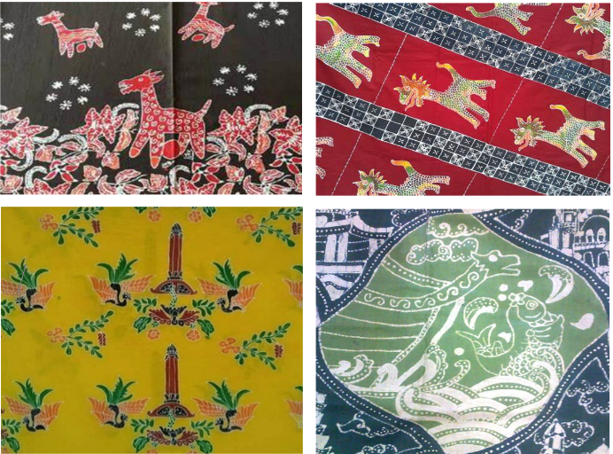

Figure 1. The old motif in Semarang was created by batik artisans

Since it was recognized as an intangible world cultural heritage by UNESCO on October 2, 2009, Indonesian batik has continued to develop in various regions. Historically, batik was originally a textile art that grew in the palace area (Chistyakova, 2018). However, batik has continued to develop outside the palace to the northern coastal areas of Java, such as Brebes, Pekalongan, Semarang, Jepara, Cirebon, and Lasem, as part of the past trade commodities in the spice route in its development (Budianto & Sunarya, 2021; Sugiarto et al., 2020). According to the results of the study, batik is a woman's job on par with other houses works which has been mostly done in Solo, Pekalongan, and Lasem, including Semarang (Cahyono, 2018; Sugiarto et al., 2021; Wicaksono et al., 2017)
Traditionally, making batik requires canting and the right skills of certain artisans can do. The characteristics of batik lie in "resist dyeing" using batik wax as a barrier substance and canting or stamp (copper stamp) as a tool to attach wax to the textile surface (Poon, 2020; Rudolf, 2012). Batik is made through a long process and takes place from generation to generation. The traditional batik process starts from the njaplak stage, which transfers patterns from paper to cloth. Then, it proceeds to the nglowong, ngiseni, nyolet, mopok, nembok, and ngelir stages.
Semarang Batik is located in ​​Semarang City, which has been well-known as a batik producer in Central Java. Judging from the characteristics of motifs, colouring, and textile-making techniques, batik Semarangan belongs to the coastal batik genre. However, the results of previous studies show that the development of batik Semarangan motifs tends to be stagnant compared to its surroundings, including Pekalongan, Solo, and Lasem (Angkawijaya et al., 2020; Sugiarto et al., 2020; Syakir, 2019; Syamwil et al., 2019). So far, the form of batik Semarangan motifs has been limited to the representation of images/objects of Lawang Sewu, Tugu Muda, and Warak Ngendok, a low art motif creation strategy.
This problem can be overcome by reconstructing batik Semarang with aesthetic-dichotomous rules to create a more contemporary batik style in masculine and feminine clothing. The application of the batik design is very suitable for the identity of batik Semarangan because of its position as a metropolitan city and the potential for egalitarian coastal batik art.
2. Development of Batik Textile Based on Feminine and Masculine Style
2.1 Batik Textile Equipment
Infrastructure is a part of input, while input is a part of a subsystem. The infrastructure is needed to support the students’ skills to compete with the rapid technology. Infrastructure is required in each artisan’s location, including a workspace, showroom, office, and other regular and sustainable supporting facilities.
That infrastructure should be based on the budget owned by the batik artisan. The equipment and material used during the batik are the artisans, such as stoves, pans, canting, batik dyes, etc. Based on the researcher’s interview with the artisans, there is some equipment that the artisans have, such as 2 stoves, 10 canting, 1 bucket, 1 set of batik dye, and a drying room.
“I provide 3 stoves and pans to do batik. Not all of the stoves can be used since some of them do not worth to use. Among those 20 canting, some of them cannot be used. In addition, we also provide 2 buckets for the dyeing and pelorodan (the process of wax removal) as well as batik dyes (interview).”
The following is the equipment and material used in Batik Extracurricular.
Table 1. Media of Batik Textile in Semarang

Batik Equipment |  | Function
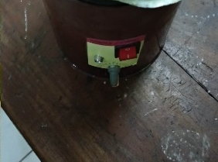 | Stove | To heat the batik dyes to use in doing batik
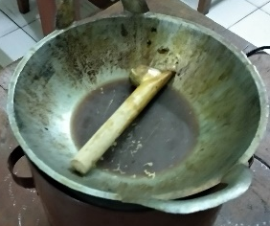 | Wok | To melt the wax and it has about 20 cm diameter.
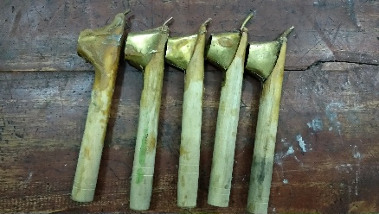 | Canting | The media to draw the wax on the textile, which is made of thin copper or brass plate used as the writing media of batik.
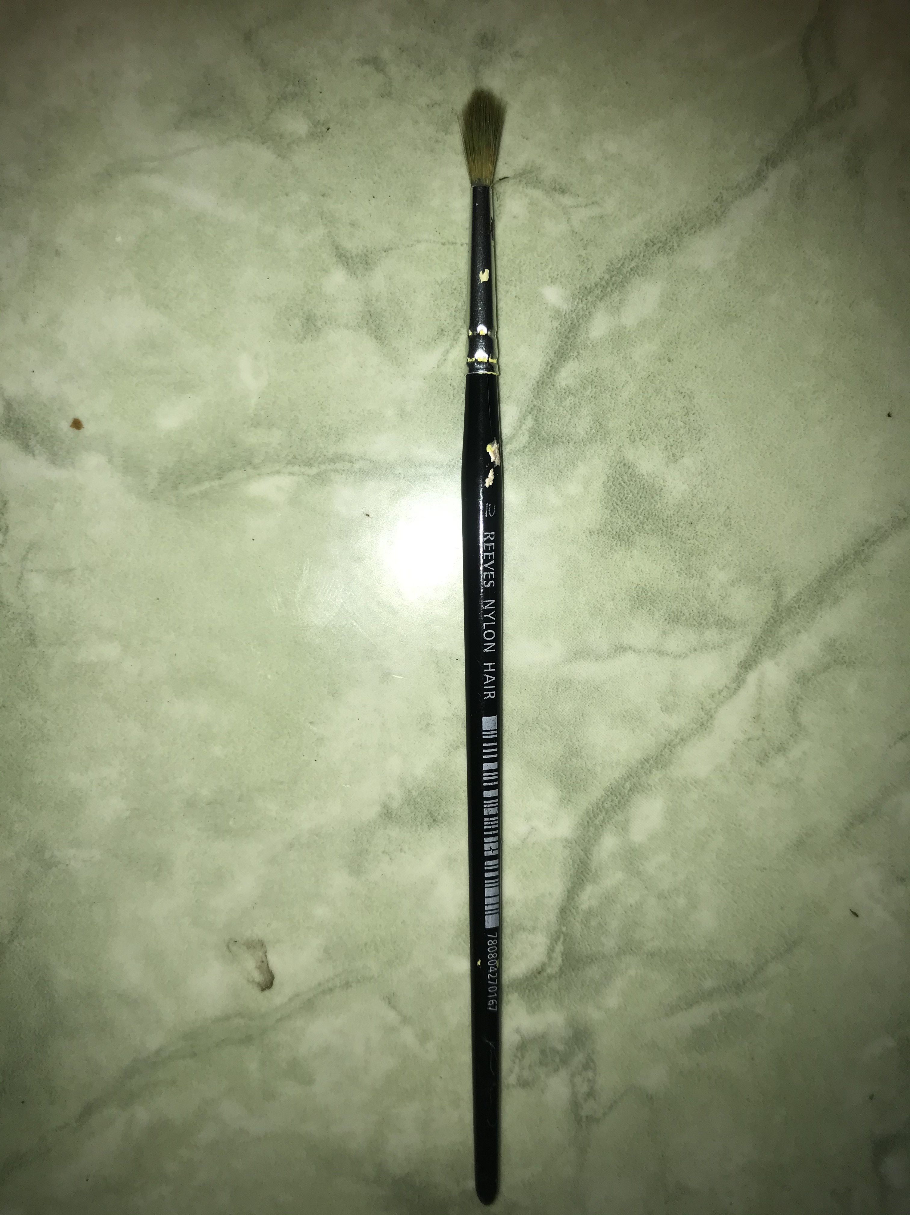 | Brush | To give color to the textile.
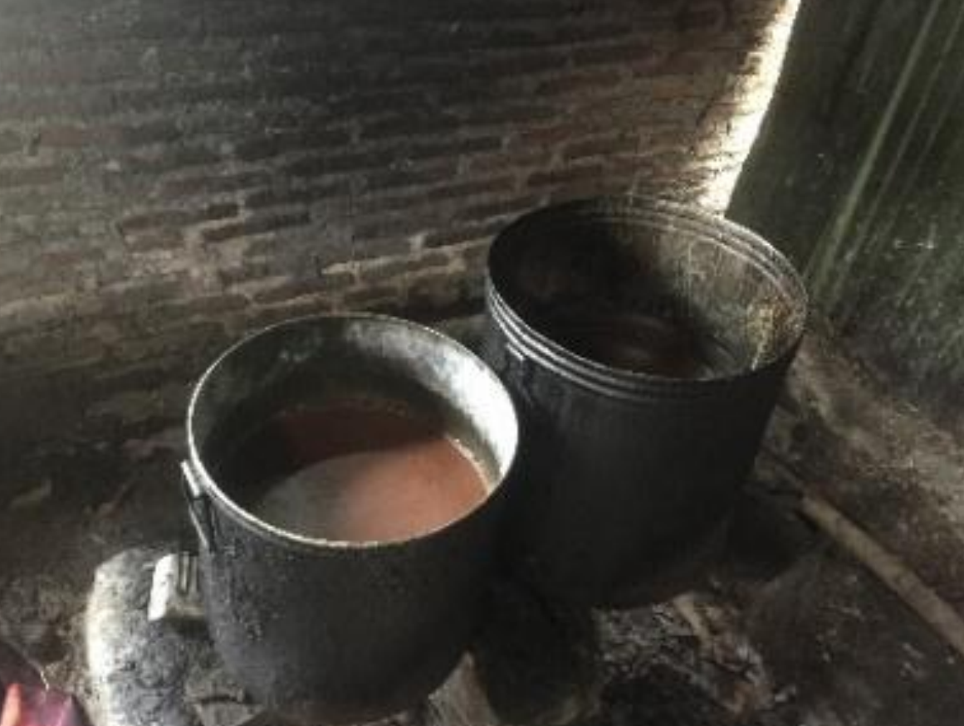 | Pan | It is made of aluminum so it can resist heat, and it has about 50 cm diameter and 60 cm of height
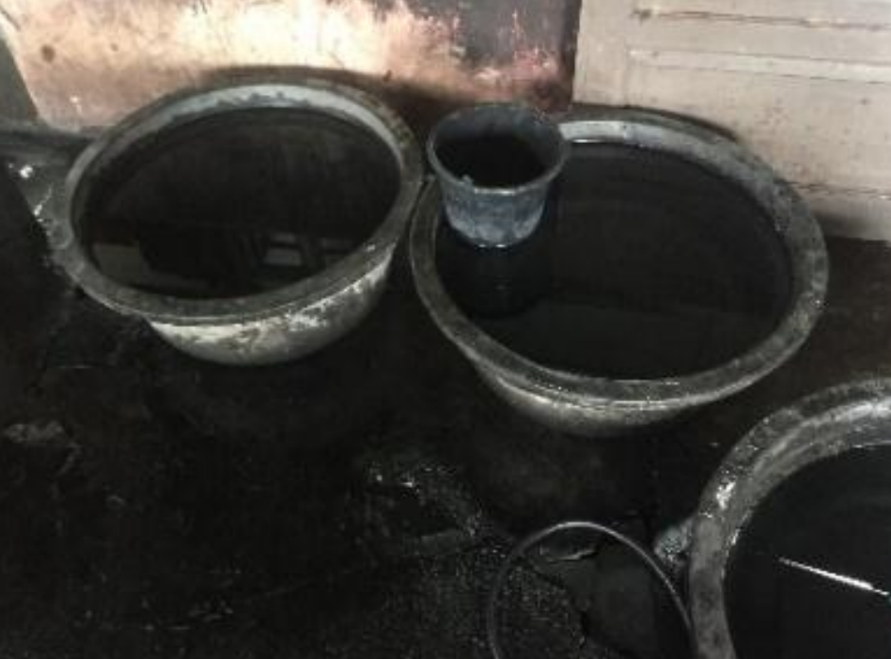 | Bucket | Big buckets made of plastic with 60 cm in diameter and 45 cm in height
Batik Materials |  | Function
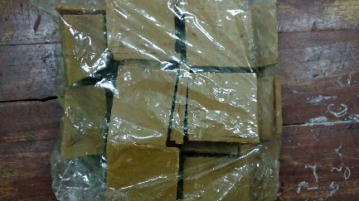 | Waxx | To cover the textile from the dyeing process, so the covered textile will not get colored.
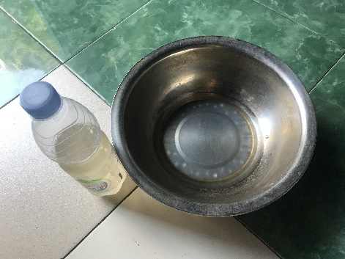 | Waterglass | To lock the dye on the textile.
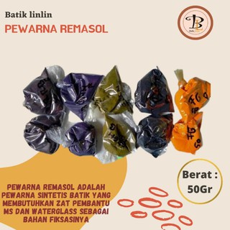 | Remasol | The batik dye that is used to mencolet (dye the textile using a particular brush)

2.2. The Making Process of Contemporary Batik Textile
The motive design creation is conducted using manila paper. The design making consists of two ways. First, it uses manila paper which is drawn using a pencil and thickened using markers starting from the main shapes and supporting motives until isen-isen. It is then redrawn by tracing supported by the light under the glass table so the motive is visible and transparent. Second, the artisans can directly use batik motive design using pencil on the textile. From the making point of view, batik is categorized into two, namely first, the idea and the making of batik motive is conducted by the artisans. Second, the idea and making of the batik motive is decided by the customer and made in the form of a batik motive design.
The equipment and material used in the making include cotton textile, wax, textile dyes, and sodium carbonate. While the equipment used in the technique making includes canting, wok, stove, gawangan, bucket, plastic, and clothesline.
The making process starts from the conceptual step includes: 1. Finding the idea; 2. Data and sources collection; 3. Concept composition of the design. The following visualization step includes 1. Sketching on the paper; 2. Apply the sketch on the textile media; 3. Do canting (ngelowongi); 4. Blocking (mopoki); 5. Dyeing (immersion 1); 6. Dyeing (immersion 2); 7. Pelorodan (wax removal); 8. Drying; 9. Finishing.
First is the media on the cotton textile. The sketching process is using a pencil on the tracing paper. The motive sketch on the tracing paper is moved to empty cloth, the premium cotton textile type that is great for batik because it has high absorption. The artisans make the batik design on textiles or make patterns. In this step, the artisans draw the pattern (decoration) on the textile using a pencil. The pattern is made on the drawing desk by spreading the textile and drawing it. The motive and pattern are based on the artisans’ wishes or inspiration. However, if there is any order for a specific motive, the pattern will be based on the customer’s order.
Second, after the molani (tracing) process, the next step is “nyanting” or “nglowong” (the process of attaching the wax to the textile using canting), the pattern using wax. In this step, all drawn motives are covered with wax so that the motives can be formed based on the pattern drawn. This process is conducted on the textile using canting according to the sketching pattern. This step covers certain textile parts so they cannot get dyed.
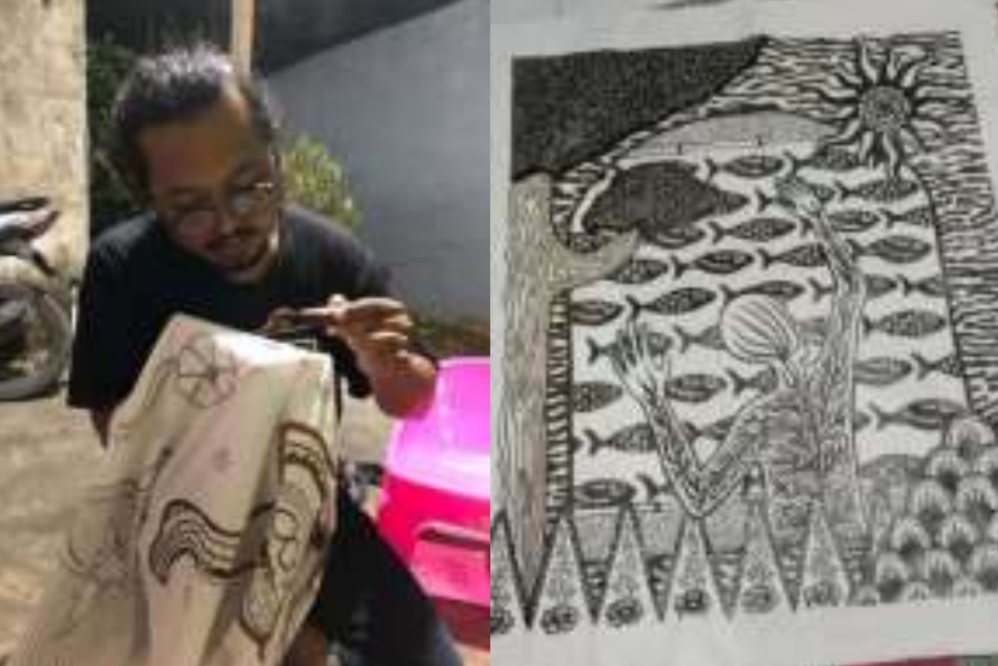

Figure 4. Traditional process of ‘nyanting’ or nglowong’
The third process is “ngiseni,” or giving isen-isen (decoration) on batik. It aims to add aesthetical value to batik and decorates the main and supporting motives. Making isen-isen uses canting filled with wax, the same as the tracing process.
Fourth, “nemboki” or blocking is the process of attaching the wax to a specific part of the textile so its color will not change after the second dyeing process, which is already after the drying process. The batik textile, then, is covered using wax on the desired part. It uses a bigger canting, which is called canting book/tembok.
Fifth, “nyolet,” or coloring, uses a brush. This step gives the main and supporting motives a color based on the customers’ wishes or orders. The artisans do not use a standard brush or special brush to attach the color to the textile so that it can fill all its motives. Fifth, mopok or covering certain part that has been dyed using wax. It aims to cover the colored motive using a brush. The motive that has been dyed is covered by wax, so in the immersion on the dyeing bucket; the color will not be mixed with the base colors of the textile.
Among the synthetic dyes used in the batik process, naphthol is the most used because it can be used quickly for the dyeing (immersion) process, and the color is intense. It consists of two substances: naphthol AS as the base color and diazonium salt as the color generator. This substance is used as a dye in the batik process, and the naphthol most commonly used in batik as naphthol AS, naphthol ASG, naphthol AS-BR, and sogan. In comparison, the color generator used is BB, GC, GG, and R.
Sixth, the next step is ngelir or whole dyeing. It is the process of dyeing the uncovered part of the textile with the wax by immersing the textile in a specific color.

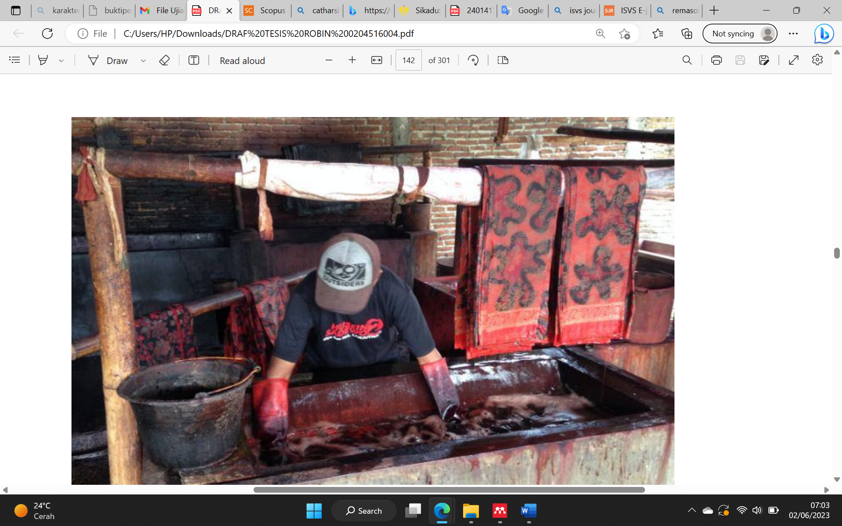

Figure 3. Process of full coloring
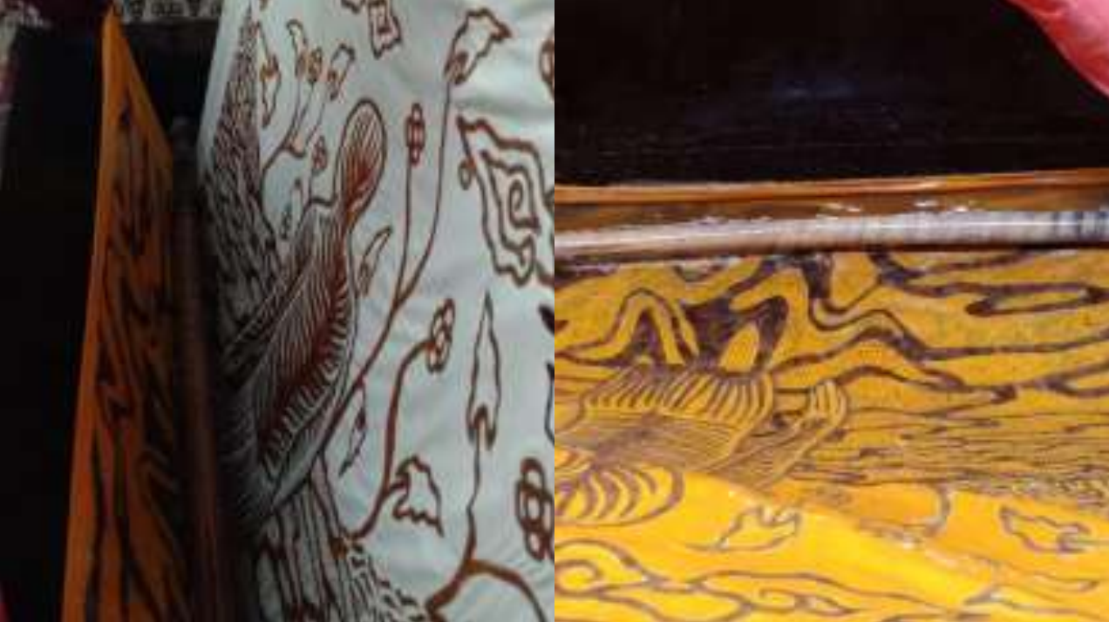

Figure 4. The result of the first immersion

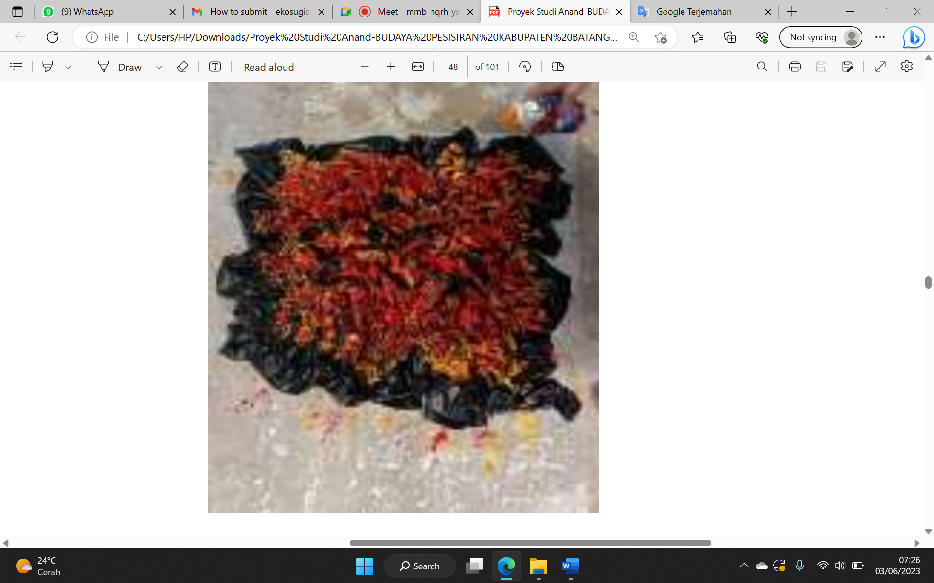

Figure 4. First immersion
The second immersion has the same technique as the first immersion. The dye substance is the same as the first, using Indigosol. However, the color used is darker to make different colors as the first immersion. Seventh, the ‘nglorot’ process removes the wax from the textile by boiling it in hot water on a barrel and then drying it.
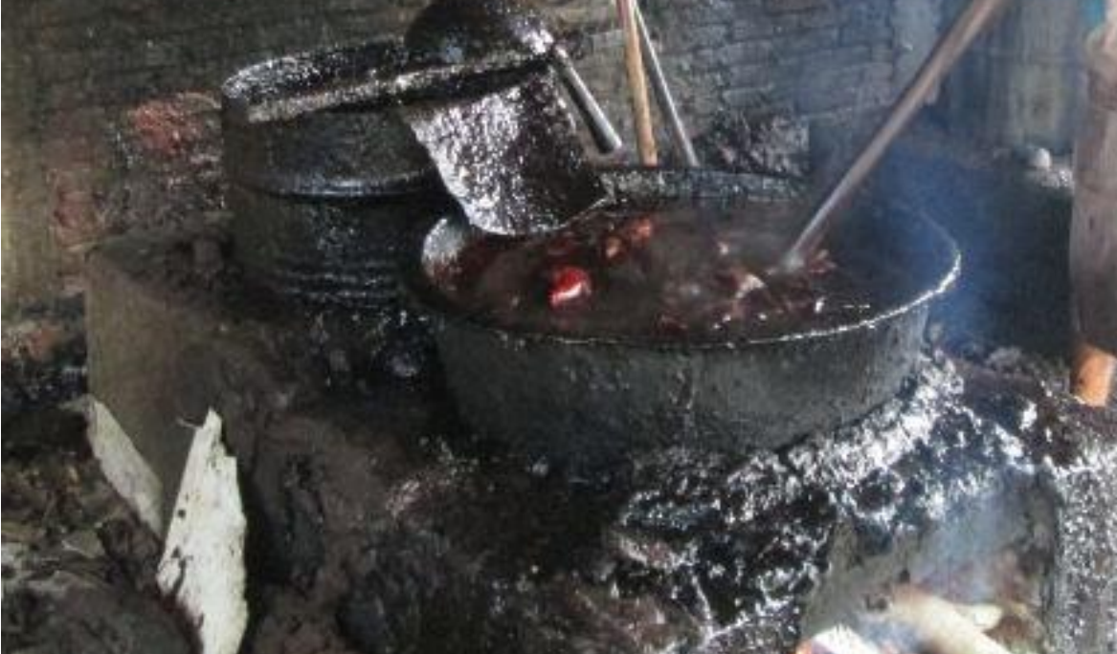

Figure 5. Cleaning of the wax in traditional process of batik
All of the batik process is cleaned using a cleaner bucket. It is conducted by immersing the batik textile after wax removal so that it can clean the rest of the wax. The water on the bucket is permanently changed to keep it clean, and the rest of the wax will not stain the batik.
The uniqueness of development contemporary batik in its patterns. The patterns of batik Semarang are free to be combined with any decoration. In addition, with the same decoration, the patterns applied by the manufacturer must be different. The experience and creativity of producers are factors that determine the uniqueness of the product.
The enthusiasts of batik Semarang are not only in the scope of the community from Semarang City but also visitors from outside the region who are starting to be interested in the original products of Semarang. The high price of the written batik is not a problem for them. Based on the interviews between the researchers and the producers and entrepreneurs of batik Semarang, the number of consumers is also increasing. It has proven that the consumer interest and purchasing power for Batik Semarang is increasing.
The quality of its designs determines the future of batik Semarang. However, it is difficult to compete with batik from Solo, Jogja, or Pekalongan. Therefore, a new identity is needed for its development. The designs with a contemporary taste oriented towards women's and men's clothing need to be developed. The following is the result of the development of batik Semarang.
Batik Semarang can also be referred to as a decoration and expression. In other words, the imagination of an individual or group expresses the state of oneself and the creator's environment through the depiction of ideals, meanings, and feelings. The variety of creation of ornaments is generally influenced and closely related to several factors, such as the geographical location of the batik maker producer, the nature and livelihood of the area, beliefs and customs, the surrounding natural conditions, including flora and fauna as well as the relationship between batik areas one another. The use of line and rhythm between lines is further explored during the creation of the contemporary batik.

2.3. Development of Batik Textile Product 1

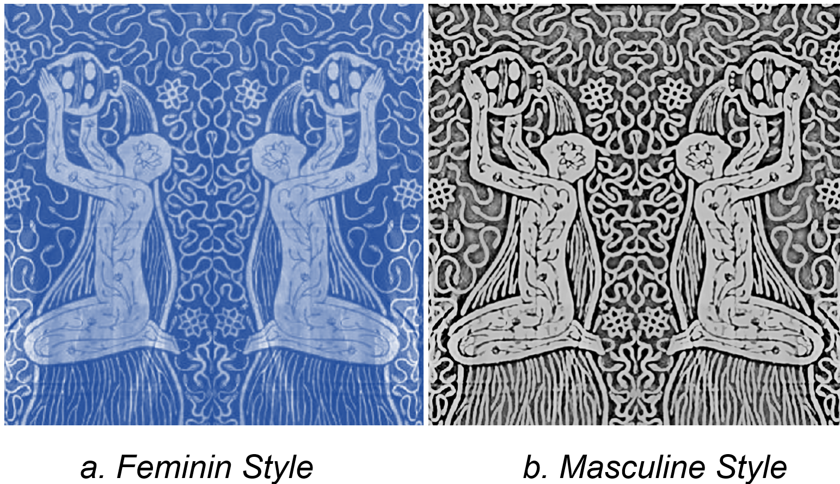

Figure 6. Batik Product 1
The products of contemporary batik 1 are the batik creation on cotton textile 60x150 cm in size. The main object of motive is in the form of a person that is drawn in the middle of the batik area in a whole body, kneels, and pours water from the jug. Then, complete the space around the main object in the batik textile

3.4. Development of Batik Textile Product 2
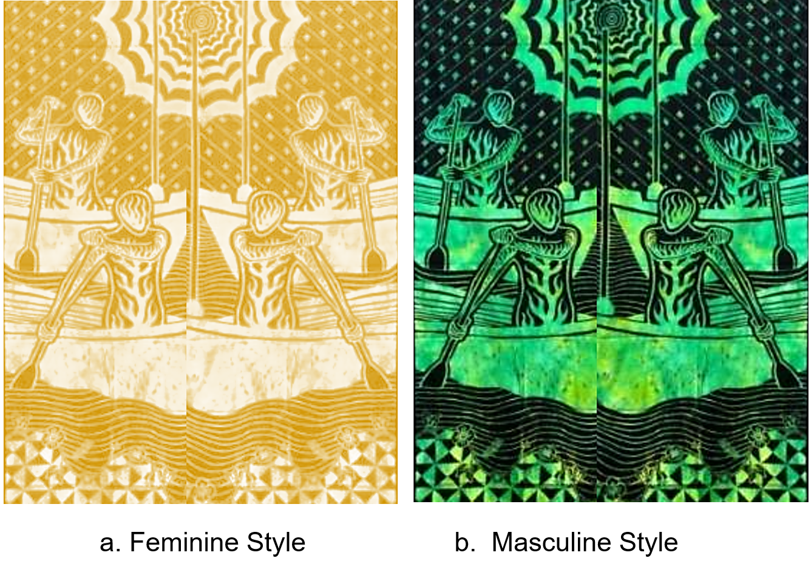

Figure 7. Batik Product 2
Product 2, titled “Lomban Dayung,” is a batik created on cotton textile 60 x 150 cm in size, using naphthol. As the main focus, there is a person in the boat who has almost filled all space of the textile, and his/her position is symmetrical between the right and left, so the space looks balanced. In addition, to complete the motive, there is a supporting motive in the form of slopping lines and dots. While to complete the upper part, there are curved lines as the water representation.
3.5. Development of Batik Textile Product 3
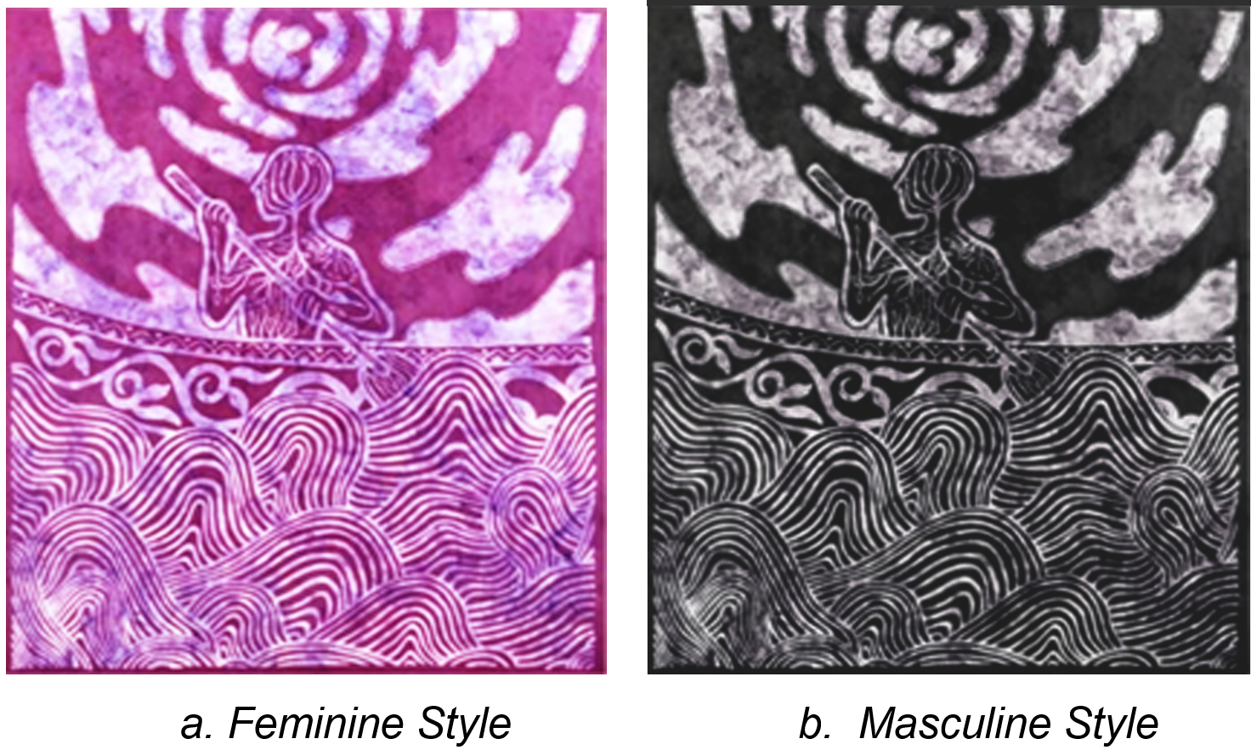

Figure 7. Batik Product 3
Figure 3, titled “Nelayan,” is a batik created on cotton textile with naphthol and 100 x 120 cm in size. Its main motive is a person in the middle of the textile area, who is only half-body, and there are rhythmic wavy lines around as well as tendril motives. Moreover, to complete the space and as the barrier of the main and supporting objects in the lower part, the craftsmen add wavy lines motive under the main object. For the base colors, the artisans use black-brownish for the masculine style and pink for the feminine style. In addition, to make the color more beautiful, the color is combined using a tie-dye technique.
3.6. Development of Batik Textile Product 4
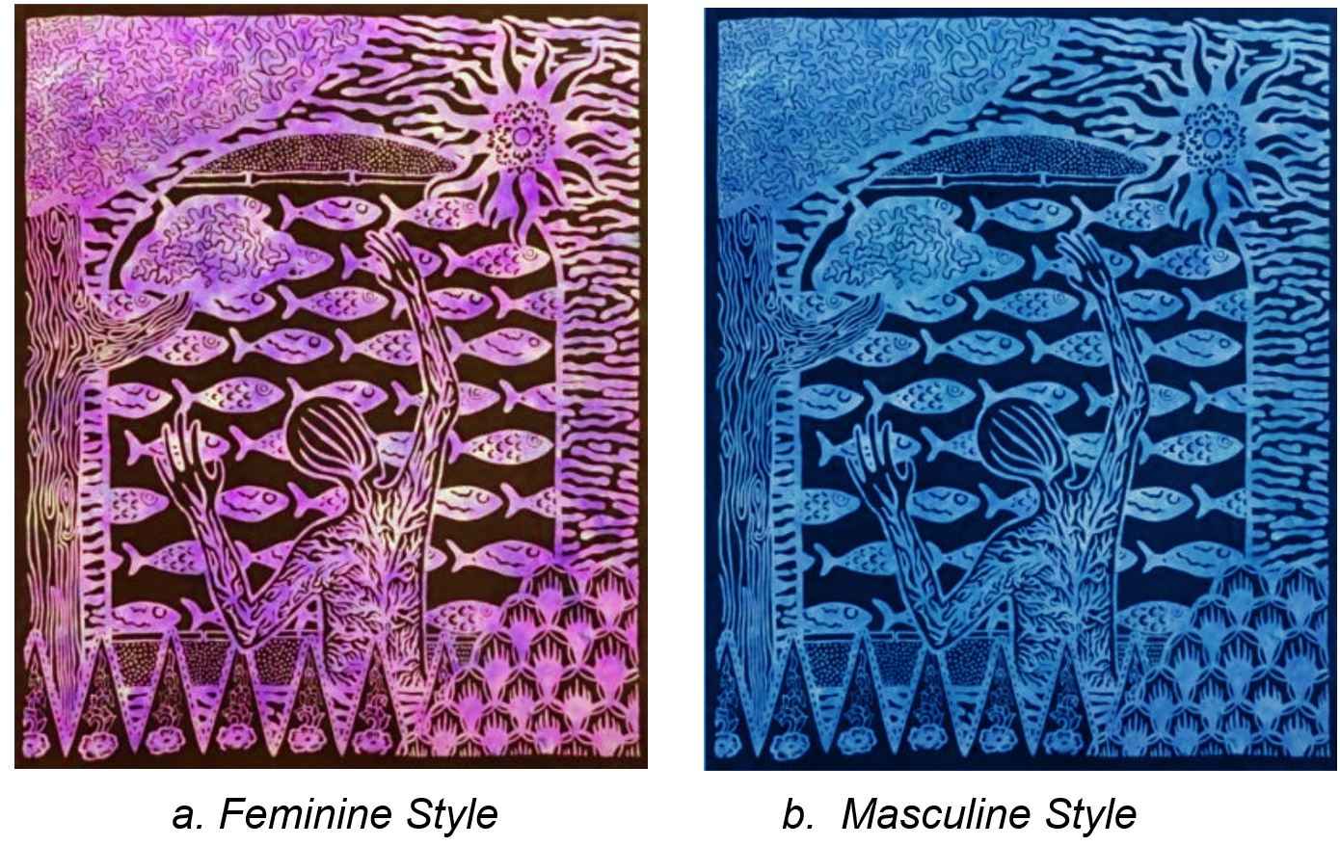

Figure 8. Batik Product 4
Product 4, titled “Mepe Gereh,” is a batik created on primissima cotton 100 x 120 cm in size. The motive is in the form of a person who is still drying green (dried fish) as the point of interest. The textile motive is seen as symmetrical between the right and left sides and balanced on the textile area. The dyeing process is conducted in two steps. The first step uses the tie-dye technique as the color, both for masculine and feminine styles. Then, the dyeing process on the background area uses darker color, dark black.
3. Femininity, Masculinity, and Contemporary in Semarang batik
Masculinity and femininity are conceptions used by social-psychological scientists as analytical categories to study society and social behaviour. Meanwhile, in the context of feminist and postmodern thought, the traditional conception of masculinity, which means to be a "real man", has been widely criticized in philosophy (James, 1997). One of the main characteristics of the masculine-feminine dichotomy concerns the sense-feeling dichotomy, a parallel and fundamental aspect of the dichotomy of masculinity and femininity. In the West, masculinity and femininity always refer to the history of symbolic conceptions of masculinity in ancient Greece, the Renaissance, and today.
Femininity or masculinity in cultural texts represents certain ideological messages instead of mere human representations. It can lead to restrictions on the roles of women and men, as well as an affirmation of what their gender roles should be. Therefore, masculinity and femininity are not solely related to gender but to human traits or character. Anyone can put himself on the masculine or feminine side by presenting the character (James, 1997).
In the aesthetic theory of the Archipelago in Indonesia, the concept of masculine and feminine does not refer to a significant distinction. However, it refers to the complement of the perfection and welfare of human life. The concept of masculine and feminine has long appeared in historical artefacts as part of aesthetic and religious elements. This appearance was initially found in many temple elements in the form of symbolic lingga and yoni (Miranti & Setiawan, 2020).
This study has succeeded in finding that the pattern of differences according to gender is seen when a work of art or design can display its masculine or feminine character. For example, pink and blue are gender colours, the former being considered 'feminine' and the latter 'masculine'. It follows the visual-perceptual theory, where the intensity of strong colours is masculine while soft colours are feminine (Jung & Griber, 2019; Monica & Luzar, 2011). Likewise, curved lines represent feminine products, with line elements and solid lines representing masculine products (Saito, 2016).
The assertion of masculine and feminine products is also recommended from a marketing perspective by Grohmann et al. in their research on gender perception to build a brand. According to Grohmann et al., symbols of masculinity and femininity discussed in the evolutionary psychology literature can be applied to new or existing brand designs (Sumardjo, 2006). Brand design elements consistently influence the perception of product masculinity and femininity. It, in turn, is significantly related to consumer preference and product equity. Perceptions of product masculinity and femininity successfully predict brand equity (Sumardjo, 2006).
The masculine and feminine batik designs with contemporary styles are applied to Semarangan batik designs by applying masculine and feminine aesthetic rules to the entire pre-production, production, and post-production processes, namely: (a) motif making, (b) motif initiation, (c) insertion/printing, (d) coloring, (e) clothing, and (f) packaging design. The application of dichotomous aesthetics is carried out on contemporary batik designs in Semarang to increase the value of batik as it has been effective in the current painting market in the world.
The keyword of contemporary in this developed batik design is "contemporary" or "newness" in postmodernism beliefs (Barry, 2018). Contemporary indicators are manifested in contemporary concepts raised (Coutinho-Sledge, 2017). Therefore, the principle of contemporary batik has been separated from the knowledge of traditional techniques that must use wax-resist dyeing. The current variations in techniques can use canting, stamping, or painting for the creation process. Contemporary batik can occupy a position as an artistic work of art.

Conclusion
Batik Semarang currently still lacks innovation. It can be shown in the early stages of research at the Citarum Batik Centre in Semarang before the design of the motif was carried out. The development of batik motifs that have been carried out still maintains the essence of batik, which is sourced from local Semarang values. The source of the idea of ​​creating motifs is the local ecological, social, and cultural environment. The orientation of the feminine and masculine characters has been determined since the beginning. The femininity and masculinity of batik motif designs are represented in the basic motifs, patterns, and colour choices of batik textiles. Batik Semarang has a strategic opportunity to be further developed in a contemporary taste. It must be able to form its own identity compared to other batiks in Java. The development of Semarang batik continues to emphasize the characteristics of being adapted to superior potential and traditional culture as well as adding elements of trends in society.
Funding: This research was funded by DRTPM Kemdikbud-Ristek and by DIPA LPPM UNNES.
Acknowledgments: The authors would like to thank to the resource persons for this research, namely craftswomen in Kauman Village in Pekalongan, Laweyan Village in Surakarta, and the Batik Figa community in Rejomulyo Village. In addition, we also would like to thank to the Research Center at Universitas Negeri Semarang for funding this study by using the DTRPM Ministry of Education and Culture funding scheme 2022 and DIPA 2023.
Conflicts of Interest: The authors declare no conflict of interest.
Disclaimer Statement
This article is written based on the results of a multi-year research on batik in Indonesia. It represents a professional research project conducted as part of the expertise of a multidisciplinary research team in the fields of fine arts, culture, and gender. This research project was evaluated by research reviewers from the Semarang State University and the Ministry of Education.
Author Bionote
Dr. Eko Sugiarto is a permanent lecturer at the Department of Fine Arts, Semarang State University, Indonesia, holding the position of Associate Professor. His research interests lie in the field of fine arts and culture. He obtained his Doctorate in Art Education from Semarang State University, Indonesia. Currently, he serves as the head of the Master of Arts Education department at the Graduate School of Semarang State University. In addition to research articles, he has also authored several reference books that have been widely cited.
Dr. Muhammad Ibnan Syarif is an associate professor in the field of fine arts and crafts at the Faculty of Language and Arts, Semarang State University. He is a permanent lecturer and also a senior researcher. He has conducted numerous research studies on art and crafts. In addition to teaching at the undergraduate level, he also teaches at the master's and doctoral levels.
Putri Khoirin Nashiroh, M.Pd. is a Master of Education specializing in electrical engineering. She often participates in batik textile research projects, particularly in the development of digital textile design technology. She has been a permanent lecturer at Semarang State University since 2018.
Anand Luthfi Maulana is a student of fine arts education at Semarang State University. He has been actively involved in batik research under the guidance of Dr. Eko Sugiarto. He specializes in the field of artistic creation methodology, particularly in traditional crafts.
Authorship and Level of Contribution
Prof. Dr. Sucihatiningsih Dian Wisika Prajanti, M.,Si. is the supervisor and reviewer of the research from which this article is derived. He contributed in terms of content and proofreading.

References
Angkawijaya, Y., Chuan, A. O. T., & Agustina. (2020). Batik as Part of Pop Culture. The 4th International Symposium of Arts, Crafts & Design in South East Asia (ARCADESA), 1–6.
Barry, B. (2018). (Re)Fashioning Masculinity: Social Identity and Context in Men’s Hybrid Masculinities through Dress. Gender & Society, 32(5), 638–662. https://doi.org/10.1177/0891243218774495
Budianto, E. R., & Sunarya, Y. Y. (2021). Jalur Rempah dan Karakteristik Batik Buketan Peranakan Tionghoa Tiga Generasi. Serat Rupa-Journal of Design, 5(2), 186–205.
Cahyono. (2018). WARAK NGENDOG DALAM TRADISI DUGDERAN SEBAGAI REPRESENTASI IDENTITAS MUSLIM URBAN DI KOTA SEMARANG. Jurnal Theologia, 29(2), 339–362.
Chistyakova, O. (2018). Postmodern Philosophy and Contemporary Art *. 4th International Conference on Arts, Design and Contemporary Education (ICADCE 2018, 232(Icadce), 131–136. https://www.atlantis-press.com/proceedings/icadce-18/25900166
Coutinho-Sledge, P. (2017). Styling Masculinity: Gender, Class, and Inequality in the Men’s Grooming Industry by Kristen Barber. American Journal of Sociology, 123(1), 327–329. https://doi.org/10.1086/692436
Fadlia, A. (2018). WOMEN AND BATIK RIFA ’ IYAH. 2 Nd International Conference on History Education 2018, 31–35.
James, C. A. (1997). FEMINISM AND MASCULINITY: RECONCEPTUALIZING THE DICHOTOMY OF REASON AND EMOTION. International Journal of Sociology and Social Policy, 17(1/2), 129–152. https://doi.org/10.1108/eb013296
Jung, I., & Griber, Y. (2019). Colour associations for the words feminine and masculine in nine different countries.
Kemenparekraf. (2018). Local Creative Economy Believed to be Globally Contributing to GDP of up to 1,100 Trillion (Ekonomi Kreatif Lokal Diyakini Mampu Mendunia Sumbang PDB hingga 1.100 Triliun.
Kishore, N., Paul, S., Grover, E., & Maurya, S. (2013). Adaptation of Monumental Motifs for Textile Application. Asian Journal of Home Science, 8(2), 726–730.
Krisnawati, E., Sunarni, N., Indrayani, L. M., Sofyan, A. N., & Nur, T. (2019). Identity Exhibition in Batik Motifs of Ebeg and Pataruman. SAGE Open, April-June, 1–7. https://doi.org/10.1177/2158244019846686
Miranti, P. K., & Setiawan, A. (2020). PESAN GENDER PADA RELIEF-RELIEF CANDI SUKUH: FEMINISME MELALUI PENDEKATAN TUBUH DAN SEKS [GENDER MESSAGES IN THE RELIEFS OF CANDI SUKUH: FEMINISM BY APPROACHES OF BODY AND SEX]. Naditira Widya, 14(1), 19–34. https://doi.org/10.24832/nw.v14i1.409
Monica, M., & Luzar, L. C. (2011). Efek Warna dalam Dunia Desain dan Periklanan. Humaniora, 2(2), 1084. https://doi.org/10.21512/humaniora.v2i2.3158
Mukaromah, M., & Kumalasari, A. (2020). Identitas Bangunan Kota Lama sebagai Bagian Komunikasi Persuasif dalam Pariwisata. Jurnal Adharupa, 6(2), 17–23.
Poom, S. (2020). Symbolic Resistance: Tradition in Batik Transitions Sustain Beauty, Cultural Heritage and Status in the Era of Modernity. World Journal of Social Science, 7(2), 1–10.
Poon, S. (2020). Symbolic Resistance: Tradition in Batik Transitions Sustain Beauty, Cultural Heritage and Status in the Era of Modernity. World Journal of Social Science, 7, 1. https://doi.org/10.5430/wjss.v7n2p1
Rohidi, T. R. (2014). Metodologi Penelitian Seni. Cipta Prima Nusantara.
Rudolf, G. S. (2012). Batik From the Court of Java and Sumatra. Titian Foundation.
Sadtiti, S. (2016). Gambang Semarang: Sebuah Identitas Budaya Semarang yang Termarginalkan. Imajinasi Journal, 10(2), 1–14.
Saito, M. (2016). Comparative (Cross-Cultural) Color Preference and Its Structure. In M. R. Luo (Ed.), Encyclopedia of Color Science and Technology (pp. 514–520). Springer New York. https://doi.org/10.1007/978-1-4419-8071-7_73
Sobandi, B., & Rohidi, T. R. (2021). THE USE OF CLOVE LEAVES ( Syzygium aromaticum L .) AS NATURAL DYE FOR BATIK PRODUCTION IN KASUMEDANGAN BATIK INDUSTRY , INDONESIA. Vlákna a Textil (Fibres and Textiles), 28(1), 86–94.
Sugiarto, E., Othman, A. N. bin, Triyanto, & Febriani, M. (2020). REGIONAL ICON MOTIFS : RECENT TRENDS IN INDONESIA ’ S BATIK FABRIC DEVELOPMENT. Vlakna a Textil (Fibres and Textiles), 27(1), 93–98. http://vat.ft.tul.cz/2020/1/VaT_2020_1_14.pdf
Sugiarto, E., Triyanto, Febriani, M., & Nashiroh, P. K. (2021). WOMEN’S EXPRESSION IN CONTEMPORARY BATIK FABRIC IN INDONESIA. Vlakna a Textile, 28(3), 94–99.
Sullivan, G. (2005). Art Practice as Research: Inquiry in the Visual Arts. Sage Pub.
Sumardjo, J. (2006). Estetika Paradoks. Sunan Ambu Press.
Syakir, S. (2019). Semarang Batik as an Artistic Representation of Coastal and Egalitarian Communities. Proceedings of the 2nd International Conference on Arts and Culture (ICONARC 2018), 207–210. https://www.atlantis-press.com/article/125911198
Syamwil, R., Sugiarto, E., Rohidi, T. R., & Nurrohmah, S. (2019). Weeds as a source of development idea on batik motive. Vlakna a Textil, 26(2), 71–75.
Triyanto, Mujiyono, & Sugiarto, E. (2020). Values of the Authority of Local Art Coaches as a Source of Learning for Multicultural Education. International Journal of Innovation, Creativity and Change, 11(4), 463–480.
Utama, N. J., & Lusianto, J. F. (2019). Jejak Historis dan Peranan Sungai di Kota Semarang pada Awal Abad 20. 8(2), 135–145.
Wibawanto, W. (2022). Functionalization of D-Batik Technology in Digital Motif Creation. Universitas Negeri Semarang.
Wicaksono, H., Putri, N. A., & Fatimah, N. (2017). Construction of Sexual Identity and Expression of Semarang Adolescents in the Global Economy: A City Ethnographic Adolescent Approach. KOMUNITAS: International Journal of Indonesian Society and Culture, 9(1), 48–60. https://doi.org/10.15294/komunitas.v9i1.8188

