Compositions of song Nakhon Champasri for creative research and music instruction in contemporary Isan Folk Music ensemble

Akapong Phulaiyaw¹, Sayam Chuangprakhon^{1*}, Arthit Khamhongsa¹,
Narongruch Woramitmaitree¹, Warakorn Seeyo¹, Weerayut Seekhunlio¹, Pitsanu Boonsrianan¹
Sarawut Choatchamrat¹, Sittipong Yodnon² and Chatchawal Soigudrue³
¹ College of Music, Mahasarakham University, Thailand.
² Lopburi College of Dramatic Arts, Bunditpatanasilpa Institute of Fine Arts, Thailand.
³ Faculty of Education, Roi et Rajabhat University, Thailand.
* Corresponding author: sayam.c@msu.ac.th
ORCID ID: 0000-0002-5124-2953

Abstract
The compositions of "Nakhon Champasri" for a contemporary Isan folk music ensemble, focusing on creative music and music instruction in a contemporary Isan style. The objective of this was to produce academic works that advance the understanding of creative music and contribute to broader research in music, the arts, and culture. Using a creative research approach, incorporating traditional Thai Isan folk melodies and infusing them with intriguing patterns, rhythmic rise, Western harmonies, and chords, such as random notations, block chords, pentatonic scales, passing notes, rhythmic patterns, ostinato, improvisation, and passing notes, while utilizing harmonies of different voice counts The findings showcase the successful integration of traditional Isan folk melodies with contemporary compositional techniques, resulting in captivating and harmonically rich compositions. The practical implications of its value as a teaching tool for students pursuing a Bachelor of Music degree, allowing them to explore and learn about contemporary Isan folk music composition, these compositions offer opportunities for musicians and music enthusiasts interested in general music composition to engage with and appreciate the unique genre of contemporary Isan folk music. contributing to the advancement of creative music and serving as valuable resources for music instruction.

Keywords: Music Composition, Isan folk music ensemble, Contemporary Music

Public Interest Statement
This study on the compositions of "Nakhon Champasri" in contemporary Isan folk music aims to bridge the gap in existing literature by exploring the creative potential of traditional melodies infused with contemporary elements. The research holds significance for both the academic community and music enthusiasts, as it enhances our understanding of Isan folk music's evolution and showcases its cultural value. By highlighting the harmonically rich compositions and their practical implications, this study contributes to the preservation and appreciation of this unique musical tradition in the public domain.

1.0 Introduction
The Thai people constitute an old tradition of civility that has encouraged art and culture that reflect human knowledge in the creation of a stunning and priceless national legacy that responds to emotions and feelings as an expression of race or cultural traditions in all four regions. Southeast and Central Thailand's Isan region has historically been a rich region. It is clear from history that Isan is a region with year-round traditions and ways of life. especially when it relates to customs that reflect a way of life that spans the entire year. enhancing one's professional spirits in addition. There are also numerous forms of celebratory entertainment, with amusement being considered while constructing tools or musical instruments from materials found in the area that are utilized to complement the rhythm of the villagers. Making drums, votes, cans, harps, and omens, such as (Keyes, 1967; Weesaphen, 1990; Rigg et al., 2008).
The art of music is really valued. People have used music's usefulness for a variety of rituals and amusement practices related to a wide range of current beliefs (Elliott, 1991; Radocy & Boyle, 2012). When it comes to entertainment, music uplifts the spirit, and it is obvious that there is typically joyous enjoyment wherever there is music. When it comes to rituals, some think that music may solve mysterious secrets. Humans have created a variety of rituals based on their religious convictions, including sacrifices and offerings, to bring happiness and wealth to mankind as well as fertility and safety (Eliade, 1987; Polpratom, 1995).
Folk musicians' original melodies accompany Isan folk music, which expresses the mood of thought (Choatchamrat et al., 2022). Traditions are reflected in folk music. The accent of the songs on the instrument may clearly reflect these reflections because the Northeast has a hot and dry climate. The Isan people must work quickly to support their families (Nanongkham, 2011). As a result, making musical instruments is straightforward. utilize locally obtainable resources. The performances' songs, such as Krachap Pi Chao Tai, Hai Song, Seo Ka Lam, Pong Lang, and Long Drum, are quick, energizing, succinct, and enjoyable. (Chonpairot, 1983; Zawacki & de Oliveira Johann, 2014; Aho, 2016).
Folk music from Northern Isan is considered to be the most prevalent form of MoLam culture. A cairn is an instrument that harmonizes the chorus, which is referred to as a trunk. Beyond the distinctive qualities and responsibilities of Isan folk music, the MoLam Cultural Group represents the culture of the Thai Lao people that reside in almost all of Isan. The Northeastern population relies on pre-existing music for leisure and easily accessible community entertainment (Wei & Karin, 2021; Champadaeng et al., 2023).
Isan music can be created and tailored to a wide range of melodies, and it can also be performed alongside Western instruments (Yannavut, 2016; Miller, 2020). Using the Isan folk ensemble to perform on piano and keyboards was something the researcher was interested in in order to set the scene for the conceptual narrator of the story. In Nadoon District, Mahasarakham Province, there is a historic city with the name Nakhon Champasri. Migration affects the development of cities, the advancement of society, and the decline of formerly thriving cities. A continuation of the intellectual investment in Isan and the development of Isan arts and culture is the introduction of an Isan folk melody designed to be played alongside Western music.
2.0 Literature Review
Isan folk music is an art and a culture that have been passed down via numerous ethnic groups for a very long time in Thailand's northeast. Popular Isan folk songs contain distinguishing qualities that set them apart from songs from other genres, and these qualities were passed down from the past to the present. The music is composed in a succinct, entertaining, and original melody utilizing a melody or a minor mode or pentatonic scale, which only has 5 notes, yet it can be produced as edifying music for performers and listeners. The employment of a quick, upbeat, and enjoyable tempo is an example of this (Occhipinti, 2020; Chaichana, 2022). Isan traditional music Concepts developed by Isan folk musicians lead to the creation of Isan folk music. By making musical instruments out of locally accessible materials, the villagers carry on their expressions and accents through oral tradition. used for enjoyment and self-confidence, as well as for traditional vocal accompaniment. The straightforward way of life of the Isan people is frequently referenced in Isan songs. It portrays the current situation of Isan society and expresses ideas, thoughts, and emotions (Choatchamrat, 2020; 2021).
2.1 The melody of Isan folk music
The word "Lai" comes from a phrase that is frequently used and means side or path, as in "long stripe," striped crosswise. When the term "Na" is used to refer to Can, it has the same meaning as the "way" or pitch of traditional Thai music playing, such as the way solely to fit the Kava "mode". In this case, the names "Lai Yai" and "Lai Noi" refer to the huge sound (low voice) and the tiny sound (high voice), respectively. Just like in other genres of music, such as traditional Thai songs, specify the length and shortness of a defined punctuation. Isan folk music has 1-4 verses of Thai, foreign, or country songs with distinct reversals. Theoretically, it is categorized as a collection of sounds in Asia, which is 5 sounds, comparable to the diatonic scale; this type of staircase is separated into 2 types: major scale and minor scale, employing just 5 sounds in accordance with global musical principles and is known as the pentatonic scale (Suwanrong et al., 2010; Meenanan, 2015; Phulaiyaw, 2021).
2.2 Champasri history
Nakhon The kingdoms of Srikottabun, Dwaravadi Intapat, and Sake Tunagar were all in the Funan period, while Champasri is from the same time period. Champasri's demise is mentioned in the book Orangana Tales: Source of the Earth during the reign of the heavens. When the crisis was finally over, Java (Luang Prabang) raised an army across the Mekong River to attack Sake Tun Nagar, as well as its satellite cities and Champasri, and the town has since been abandoned. When the residents of the Nadoon district uncovered ancient artifacts in the area of Kusantarat in 1979, they also unearthed the ruins of stupas and pagodas that had formerly housed sacred objects. They discovered numerous bronze Buddha prints among them. The Mahasarakham province later collaborated to build the Nadoon Stupa, which was based on a bronze stupa housing a Buddha relic. The Champasri dance was performed to celebrate the abundance of historic places in the province of Mahasarakham and to represent the shared pride of the Isan people. Master Chatchawan Wongprasert at Srinakharinwirot University Mahasarakham (Mahasarakham University) came up with the Nadoon artifacts, which also include artifacts from two neighbors and the Champasri dance. It is based on literature and archeological records from Champasri.
Champasri costume dance incorporates archaeological dance moves with Isan folk dances, including Phu Tai dance, Tang Wai dance, and Sang Silp Chai dance. The Northeast has been the source of Dwaravadi dance costumes and memories, with motions representing ancient dances and stopping stances representing archeological poses.
A musical instrument Phin, Khaen, ponglang, Klong (drum), vod, cymbals, and metal instruments like the steel xylophone are used to create traditional Isan music. Music that adheres to a specific musical rhythm goes along with the Champasri dance outfit. Mahori Isan Dress Code: The performers are entirely female and dress in traditional Isan silk using two sarongs, neck jewelry (over the chest), upper arms, earrings, bracelets, and a gold belt (Wongprasert, 1989).
The Mahori Isan band found in the provinces of Roi Et and Mahasarakham originated from people in Nakhon Ratchasima who already had a Mahori playing culture. The people of the Southeast, specifically those who reside in the provinces of Roi Et and Mahasarakham, as well as Surin, Buriram, Sisaket, and Nakhon Ratchasima, can be considered to share this culture. Foreigners hired by the Mahori Isan band to teach the community how to play the many musical instruments they had assembled were from the province of Nakhon Ratchasima. This is consistent with the diffusionist theories of Swich Perry Roger and Franz Boas. Over time, cultures borrow from one another. It may also come from a single source or a combination of sources, as well as through human migration (Du, Chonpairot & Karin, 2022).
The principal musical instruments that are particular to the Mahori band are located in the provinces of Roi Et and Mahasarakham, and they are combined with regional instruments based on the skill and uniqueness of each Mahori band. Wind instruments made up the majority of the musical instrumentation in the folk Mahori band, according to a study of Isan folk musicians in the Pathumrat District in Roi Et Province. The two most common ones are painting and beating machines. Each band has the following instruments: a little fiddle and a hefty fiddle; drums; xylophones; saxophones; and other instruments like Pi Noi and Pi Yai are also used (Wongnang & Champadaeng, 2017).
2.3 Inspiration and Ideas
The city of Champasri in the district served as the inspiration for the composition of Song Nakhon Champasri for a contemporary Isan folk music ensemble. A region of Dvaravati culture is Nadoon, which is in Mahasarakham province. People from different countries, like the Khmer and Laos, immigrated to Champasri, but the Khmer civilization, which is evident from the stone castle and the city that the Khmer people built, is the culture that had the most influence. The author has presented the Exodus narrative. There is a poem about the prosperity of the city using the sound of a gong as a symbol while establishing a city, building a settlement, and picking the Champasri tune as the main melody in the song. a phase of cultural change that will inevitably pass away with time, and finally, what will be passed down to future generations.

3.0 Designs/Methods/Findings/Results
3.1 Methodology of Research
The researcher has constructed and created the following data-gathering tools for research on the composition of Nakhon Champasri music for contemporary Isan folk ensembles:
1. Research equipment
1.1 Formal interview: The researcher employs it as a resource for interviews. experts in folk music to learn more about Isan folk music, specifically Lai Champasri.
1.2 Non-Participatory Observation: Take note of the Isan folk band's rehearsal and musically appropriate performance approach.
2. Data Gathering: The following is how we set up the research data collection:
2.1 Documentary research is the process of gathering data on: familiarity with Isan traditional melody patterns Concepts and hypotheses employed in research.
2.2 Field Data Gathering, Interviews: Interviews In this study, structured interviews were used.
3. Data analysis: to study the topics and conceptual issues presented in order to use the data as the basis for producing music, the researcher acquired information from documents and data collected in the field.
4. Analysis and Commentary Structure, rhythm, melody, and technique in musical compositions.
5. Making a public presentation, we performed the songs together with the compositions, and we also videotaped the performances for posting on the College of Music's online channels.
3.2 Concepts as well as techniques are included in the composition of poems.
1. The Champasri melody is utilized to perform the melody directly while utilizing the melody's progression. Rebuild the chord.
2. Music Form Structure The researcher no longer employs the song's free style of conjugation. Diatonic and modified.
3. Creating new rhythmic proportions for each verse based on the beat of folk music
4. One of the characteristics of folk music that the instrumentalist must utilize to play some lines is the use of improvisation.
5. The use of diverse musical textures, including heterophony and polyphony; monophony
6. Making the proportions of the rhythm stronger and more noticeable than the melody by using an ostinato in the beat
7. Incorporate both smooth and abrupt transitions into your writing.
8. Tonal organizations employ a key-based sound management system. Tonality is the use of a key-based sound system based on the sound ladder in music (Dhamabutra Aputra, 2011).

3.3 Mods and scales used in music composition
Figure 1. The A minor Pentatonic Scale's structure.
Source: Dariusz (2014)
Figure 2. D minor Pentatonic Scale’ structure.
Source: Dariusz (2014)

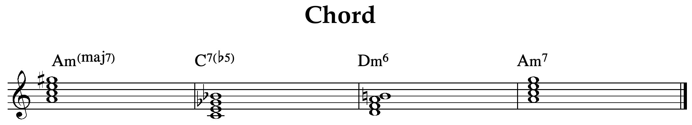
Figure 3. primary chords in the song

3.4 The scope of a musical composition
For a contemporary Isan folk ensemble, Nakhon Champasri Song uses both Western and Isan folk instruments to recreate the primary melody of an Isan folk song. Isan traditional music and 14 Western instruments collaborated for roughly 15 minutes.
3.5 The methodology used in the study
In order to find inspiration for new works, scholars have investigated information about Isan music, Isan folk patterns, and Isan culture. The procedures are: Define the song's form, including its composition. 2) Choose the primary melody from appropriate folk patterns. 3) Each verse's core idea 4) Create the motivation for each song segment and the song's primary melody (the theme). 5) To finish the song, include a linking verse in each verse. 6) Finish customizing in accordance with the research framework. 7) Make music notation. 8) Hold a concert in which you present your works. The researcher then came to a conclusion, conducted an experiment, analyzed the data, and developed a narrative that describes the findings.
3.6 Research Conceptual Framework
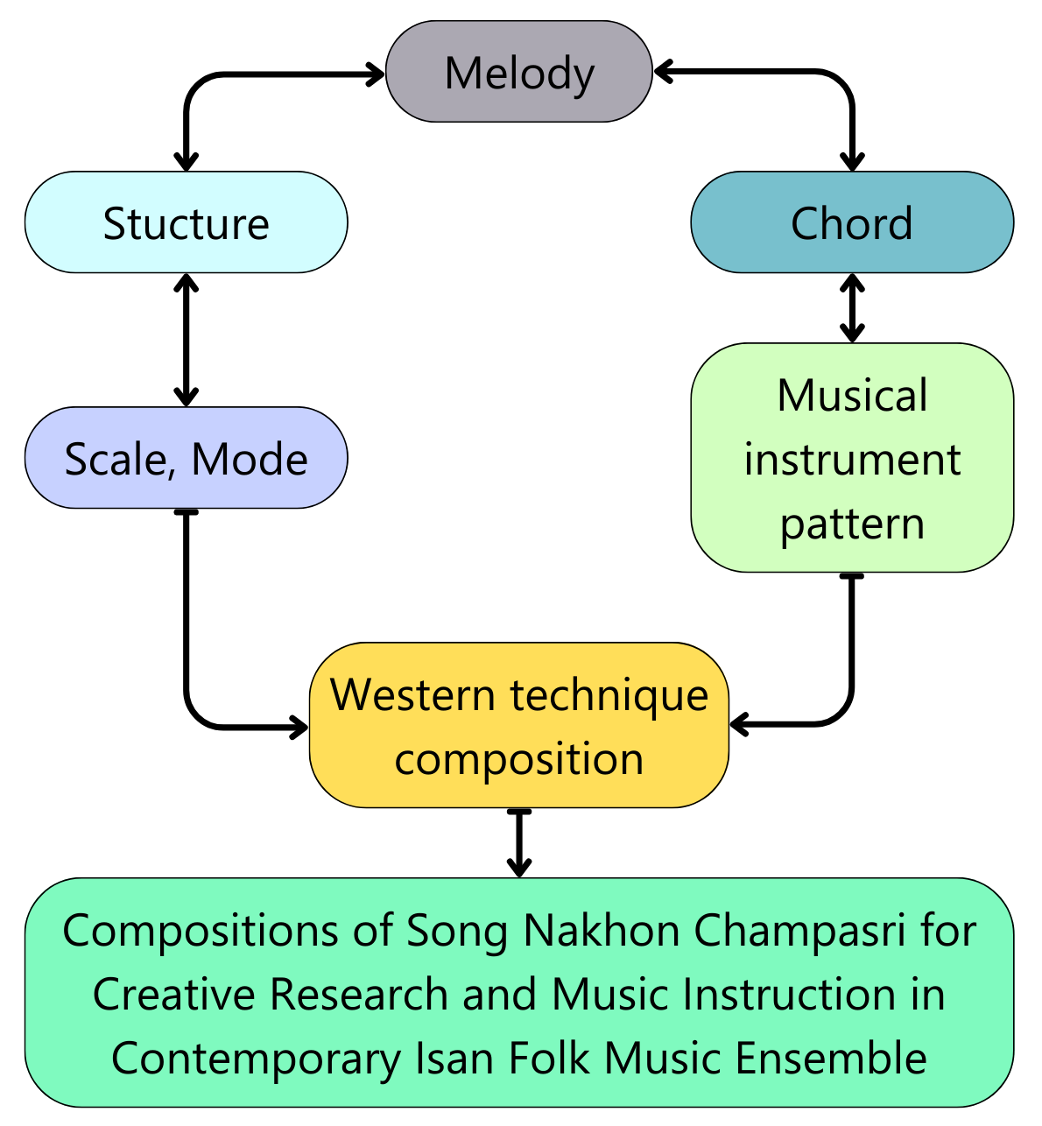
4.0 Research results
The creation of Nakhon Champasri music for all contemporary Isan folk ensembles according to the following topics:

4.1 Structure
Table 1. Structure of Song
PART | Intro | Them A | A1 | A2 | A3 | A4 | A5
BAR | 1-28 | 29-50 | 51-67 | 68-84 | 85-101 | 102-117 | 118-132
PART | A6 | A7 | A8 | transition | A9 | B | C
BAR | 133-148 | 149-164 | 165-178 | 179-188 | 189-225 | 240-303 | 304-321
PART | D | E | transition | F | transition | G | Coda
BAR | 323-349 | 350-380 | 381-384 | 385-418 | 419-422 | 423-477 | 478-484

4.2 Melody
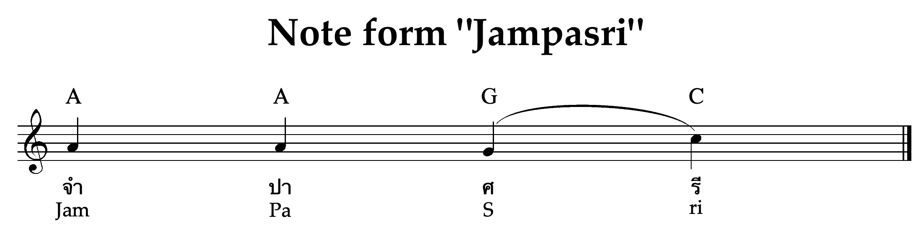
Figure 4. Notes developed from the word champasri

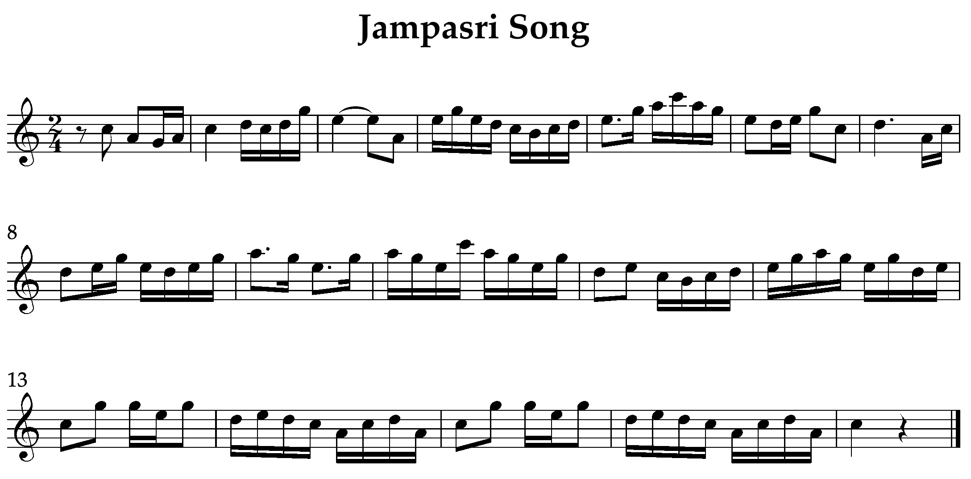
Figure 4. Main melody of Champasri

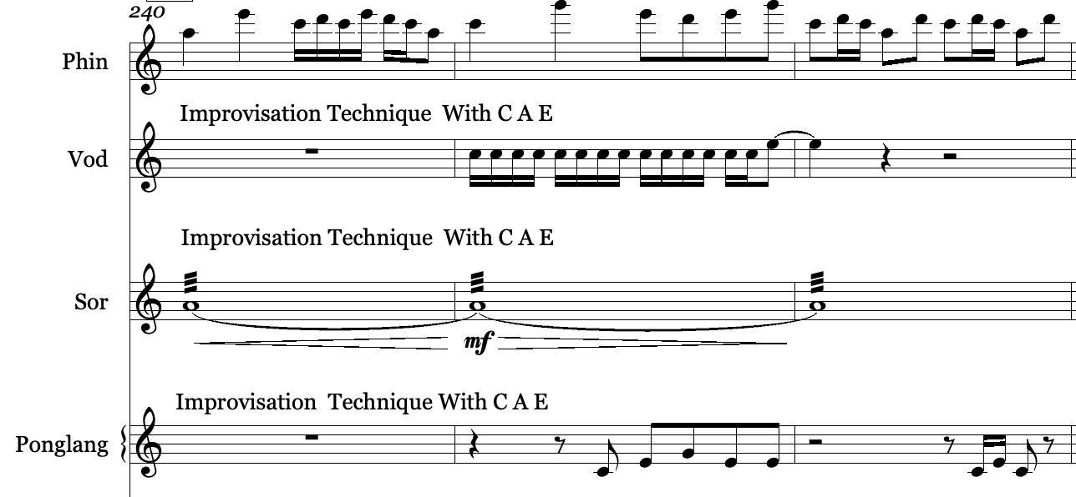
Figure 6. Improvisation Technique With C A E Note

The composer selected the notes A, G, and C as the basis for his composition, which is in the key of A minor and is derived from the name Champasri, greed and human trafficking in society.

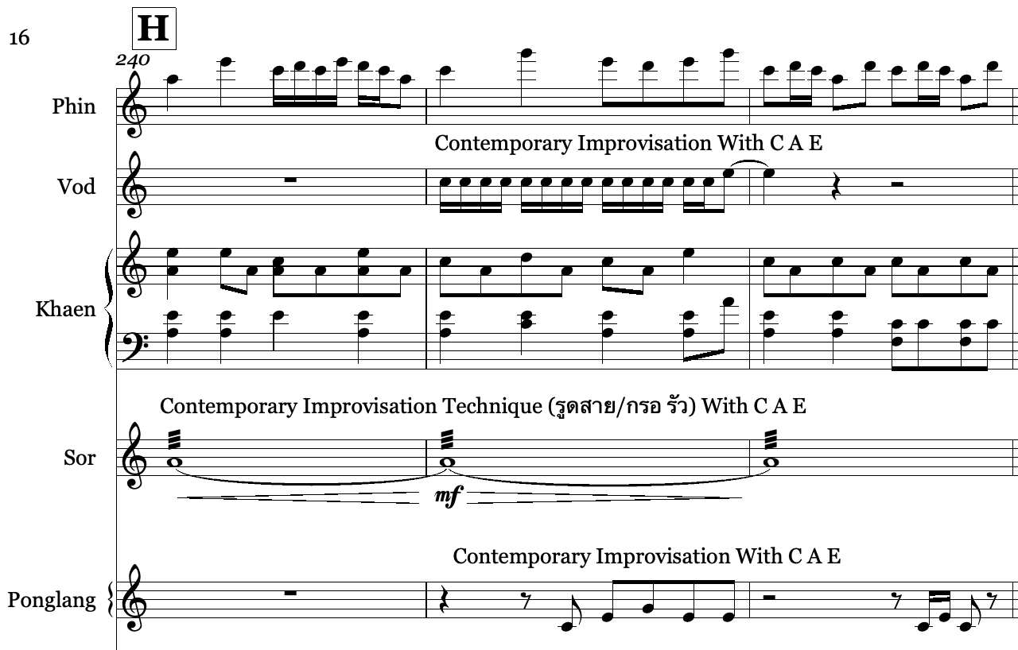
Figure 7. Contemporary Improvisation
4.3 Rhythm developed from Klongphen (Drums in Isan culture)

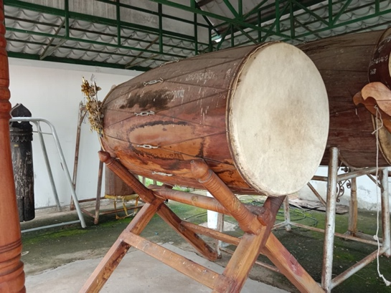
Figure 8. Klongphen (Drums in Isan culture)
Figure 9. Rhythm developed form Klongphen

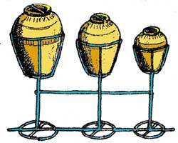
Figure 10. Hai zong
Source: https://www.isangate.com (2023)

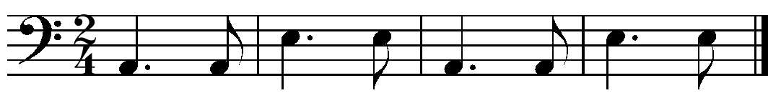
Figure 11. Original melody from Hai

Figure 12 Rhythm developed form Hai

4.4 Ensemble band pattern
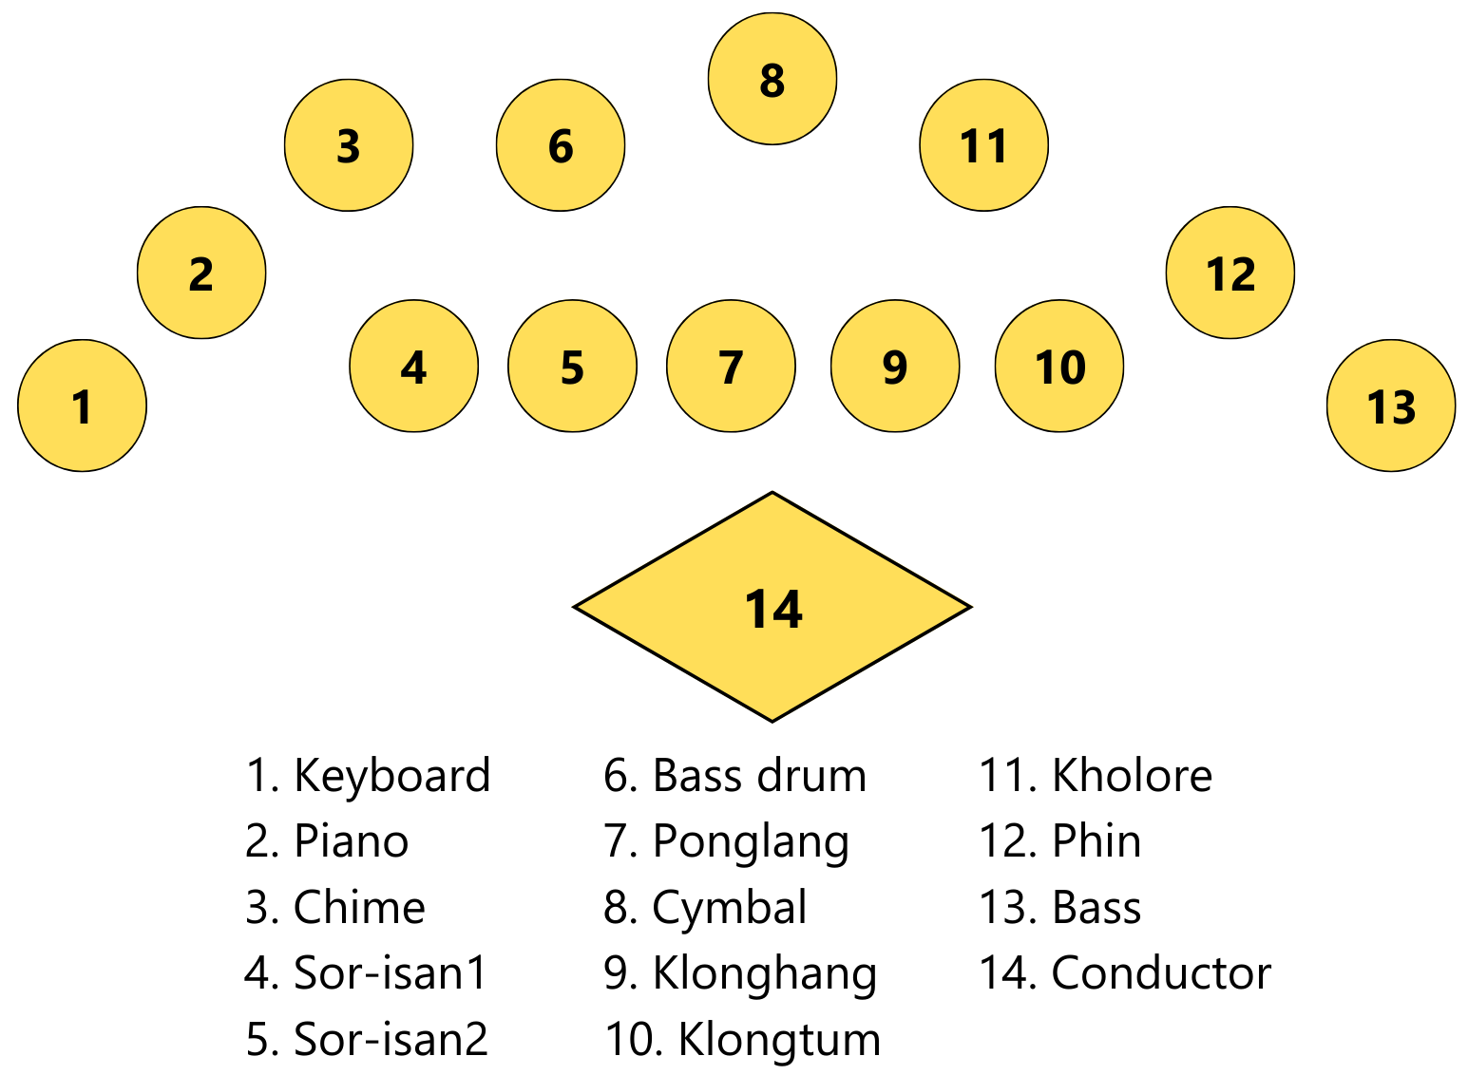
Figure 13. Ensemble band pattern

4.5 Music performance
Performed on July 22, 2022, beginning at 6:00 p.m., at the College of Music Auditorium of Mahasarakham University
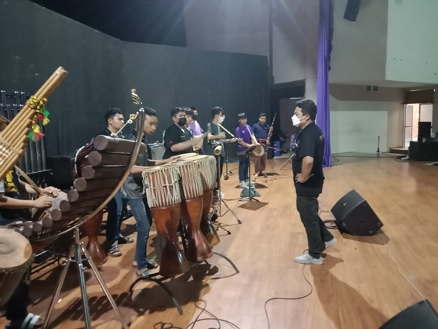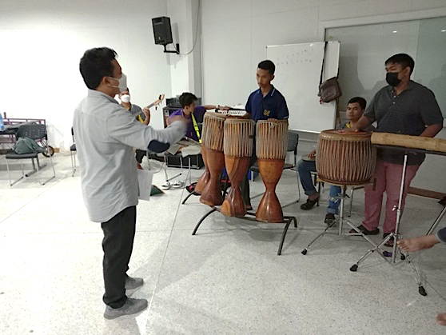
Figure 14. Rehearsal sessions for music ensemble
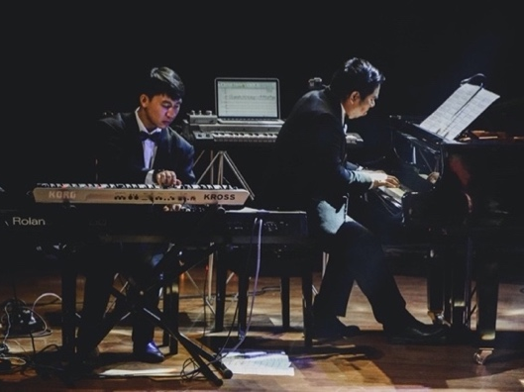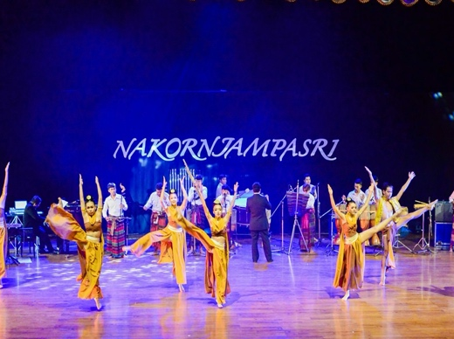
Figure 15. Nakhon Champasri Concert
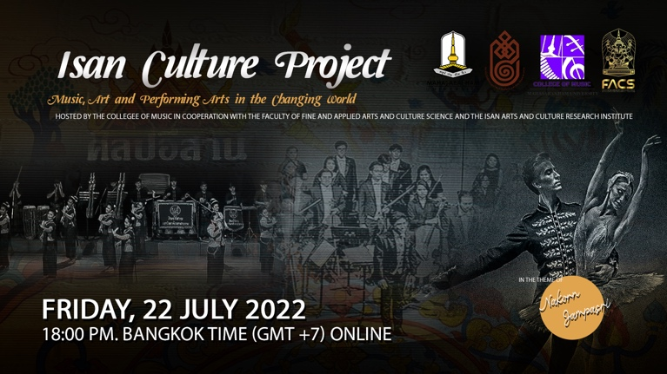
Figure 16. Poster for the Isan Culture Project event

Figure 17. QR Code and Link Music performance
Link: https://www.youtube.com/watch?v=EkYw8NepN3E

5.0 Discussion
The process of composing Nakhon Champasri music for a contemporary Isan folk ensemble draws inspiration from various sources and incorporates elements of Isan culture and literature. The goal of this composition is to produce scholarly works in music that fuse Isan folk tunes with Western musical composition styles. According to Akapong Phulaiyaw (2020) study, unity will ensure continued prosperity. An innovative piece of music, "Phungkheei," was composed. The composition tells the story of the serpent Bhangki, who transforms into an albino squirrel and visits the human city to meet Mrs. Ai but ultimately causes the city's destruction when Bhangki's father rises from the depths. Only the Nong Han rapids remain after the city's devastation.
The structure of the composition follows the following format: Introduction, A Change, Transitions, A1, A2, B, C, D, E, F, Coda: two-stage harshness To create variation, the melody is duplicated and the keys are changed. The use of an ostinato technique refines rhythmic notes into a harmonious tune. Weerayut Seekhunlio (2022) investigated how to create the harp pattern, and his research conforms to how Isan music is passed down orally (Mukkhapata). The creation of Isan harp patterns involves the selection of a master harp player who combines their imagination and originality with live pressure playing, learning from family members and folk artists, observing the way of life of the Isan people, and listening to melodies and folk patterns.
The composition's music system follows the recommendations of Narongrit Dhamabutra (2019) for implementing a sound management system based on tonality. Tonality refers to the use of a key-based sound system, and in this composition, it is applied according to the song's scale. This work serves as a valuable resource for teaching and learning about contemporary music composition and can be further developed for research into other creative works, including chamber music, thereby providing more performance opportunities. Consistent with Sakhiseni Yende (2023). Findings: Yende has conducted a study titled Sustaining indigenous African choral music identity: A study on Ndwamao George Mugovhani's composition. This article concludes by stating that the South African choral music genre has evolved into a unique genre that is rooted in indigenous African culture and identity.

Overall, the process of composing Nakhon Champasri music for a contemporary Isan folk ensemble involves drawing inspiration from Isan culture and literature, incorporating innovative techniques and elements from Western music, and adhering to sound management systems based on tonality. It offers opportunities for musical exploration, education, and future research.

6.0 Conclusion

In conclusion, the exploration of Nakhon Champasri songs for a contemporary Isan folk ensemble offers exciting opportunities for creative research. The use of Isan folk melodies serves as a central element in the production of contemporary Isan music, resulting in fresh and captivating sounds. The composition style in traditional Isan music involves the incorporation of simple harmonies, double step notes (2, 3, 4, 5, and 6), and the creation of melodies from random rhythmic sounds. Additionally, techniques such as passing notes, ostinato, improvisation, pentatonic scales, and rhythmic patterns contribute to the richness and diversity of the compositions. By embracing the richness of Isan folk music and combining it with contemporary approaches, composers and musicians can continue to explore new horizons in Isan music production. The fusion of traditional and modern elements not only adds depth and complexity to the compositions but also provides a platform for preserving and showcasing the unique cultural heritage of Isan. As further research and experimentation are conducted in this field, it is expected that the repertoire of contemporary Isan folk ensembles will continue to expand, offering both musicians and audiences a rich and engaging musical experience.

7.0 Acknowledgements

This research project was financially supported by Mahasarakham University.

8.0 References
Aho, M. (2016). The tangible in music: The tactile learning of a musical instrument. Routledge.
Chaichana, T. (2022). Jazz Orchestra Portraits of Thailand: Exploring Hybridizations of Thai Music Traditions with Jazz [Doctoral dissertation], Open Access Te Herenga Waka-Victoria University of Wellington.
Champadaeng, S., Chuangprakhon, S., Sriphet, K.& Sapso, K. (2023). Isan Khaen: Knowledge Management for Transmitting Art and Culture. International Online Journal of Education and Teaching, 10(2). 713-728.
Champadaeng, S., Chuangprakhon, S., Sriphet, K., & Sirifa, S. (2023). Literacy Transmission of Isan Lam's Melodies to Inherit MoLam's Performing Art. International Journal of Education and Literacy Studies, 11(2), 30-38.
Choatchamrat, S. (2020). Isan Popular Song and Factors Affecting Popularity of Isan Song in Thailand. Journal of Humanities and Social Sciences Nakhon Phanom University, 10(3), 76-84.
Choatchamrat, S. (2021). Context and Sustainability Promotion of Phu Thai Music, Si Thai District, Udon Thani Province. Review of International Geographical Education Online, 11(10), 21-32.
Choatchamrat, S., Phulaiyaw, A., Moonsuwan, T., Thotham, A., Chuangprakhon, S., & Phimprajun, R. (2022). A Guideline for Undergraduate Students at the College of Music, Mahasarakham University to Develop Advanced Solo in Folk Music Skills. Journal of Educational Issues, 8(2), 291-303.
Chonpairot, J. (1983). Isan folk music. Department of Music, Srinakharinwirot University, Mahasarakham.
Dariusz, T. (2014). Jazz Theory form basic to Advanced Study. Apple Books.
Dhamabutra, N. (2019). Composing Symphonic Poem Sinfonia Siamindra for Orchestra. Mahidol Music Journal, 1(2), 4-22.
Du, H., Chonpairot, J., & Karin, K. (2022). Conflict and Motivation in the Cultural Competitions of Northeastern Thailand. The International Journal of Critical Cultural Studies, 21(1), 1-9.
Eliade, M. (1987). The encyclopedia of religion (Vol. 16, pp. 277-8). C. J. Adams (Ed.). New York: Macmillan.
Elliott, D. J. (1991). Music as knowledge. Journal of Aesthetic Education, 25(3), 21-40.
Keyes, C. F. (1967). Isan: regionalism in northeastern Thailand.
Meenanan, C. (2015). The Doctoral Music Composition: Isan Symphonic Variations for Chorus and Orchestra. Rangsit Music Journal, 10(1), 23-32.
Miller, T. E. (2020). Thai Music and Dance in the Heart of Bangkok’s Slums. Contributions to Music Education, 45, 127-146.
Nanongkham, P. (2011). Modern Isan Music as Image: A Positive Identity for the People of Northeast Thailand [Doctoral dissertation], Kent State University.
Occhipinti, C. (2020). Khaen Performance: An American Perspective on Traditional Pedagogical Practices. Kent State University.
Phulaiyaw, A. (2021). Lai Lam Piano: The Isan Piano Melodies. Review of International Geographical Education Online, 11(10), 1-12.
Phulaiyaw, A. (2021). Music Composition “Phungkhee” for Saxophone Ensemble. Journal of Fine and Applied Arts Chulalongkorn University. 8(1),1-10.
Polpratom, S. (1995). The Northeastern Folk Music. Faculty of Humanities and Social Science, Udon Thani Rajabhat University.
Radocy, R. E., & Boyle, J. D. (2012). Psychological foundations of musical behavior. Charles C Thomas Publisher.
Rigg, J., Veeravongs, S., Veeravongs, L., & Rohitarachoon, P. (2008). Reconfiguring rural spaces and remaking rural lives in central Thailand. Journal of Southeast Asian Studies, 39(3), 355-381.
Seekhunlio, W., & Chuangprakhon, S. (2022). New Music for the Isan Phin Plucked Lute for the Boon Phawet Ceremony [Doctoral dissertation], Mahasarakham University.
Suwanrong, N., Samdaengdech, K., & Krairach, T. (2010). Model Development of Isan Country Song Compositions for Economic, Social and Cultural Value-Added. Journal of Social Sciences, 6(3), 474-477.
Weesaphen, W. (1990). Isan Folk Music. Centre of Art and Culture, Northeastern.
Wei, S., & Karin, K. (2021). A study of Pedagogy of Molam teaching by ChumDet Detphimon [Doctoral dissertation], Mahasarakham University.
Wongnang, A. & Champadaeng, S. (2017). Mahoree E-san Orchestra: The Development for Cultural Values Conservation. Journal of Fine and Applied Arts, Khon Kaen University, 9(2), 149-165.
Wongprasert, C. (1989). Art of dance. Academic Department, Academic Resource Center Srinakharinwirot University, Mahasarakham.
Yannavut, W. (2016). An exploration of Thai traditional music for Western percussion instruments [Doctoral dissertation], The University of Iowa.
Yende, S. (2023). Sustaining indigenous African choral music identity: A study on Ndwamaṱo George Mugovhani’s composition. Research Journal in Advanced Humanities, 4(2). https://doi.org/10.58256/rjah.v4i2.963
Zawacki, L. F., & de Oliveira Johann, M. (2014). Analogue audio recording using remote servers. Ubiquitous Music, 83-107.

